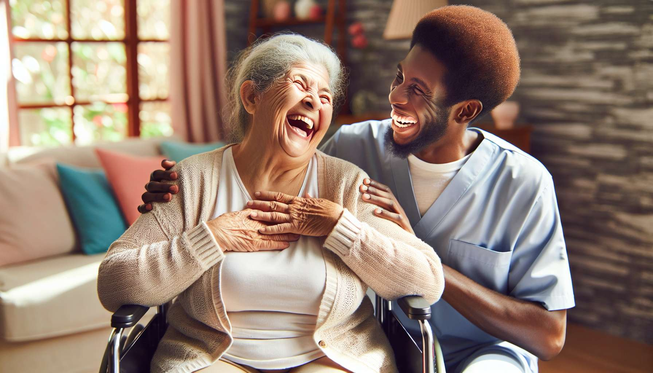

Laughter therapy finds a particularly relevant application in retirement homes and geriatric care, where it brings numerous benefits for the physical, mental, and social well-being of elderly people. Faced with the challenges of aging, such as loss of independency, isolation, or cognitive disorders, laughter appears to be a valuable tool for preserving the joy of living, social connections, and the dignity of the elderly.  
  
Physically, the regular practice of laughter exercises helps stimulate cardiovascular function, strengthen the immune system, and relieve chronic pain, which are common among elderly people. Laughter acts as a true "internal gymnastics", oxygenating the body, relaxing muscles, and activating blood circulation. Studies have shown that residents of retirement homes who participate regularly in laughter workshops have better overall health, fewer sleep problems, and greater vitality in their daily life.  
  
Mentally, laughter is a tremendous antidote against depression, anxiety, and cognitive decline. By stimulating the production of serotonin and endorphins, it provides a feeling of well-being and calm that helps fight against the gloom and loss of meaning often felt by elderly people. Laughter also promotes memory, concentration, and creativity, by activating the areas of the brain linked to positive emotions. Regular laughter workshops can thus help prevent or slow down the onset of neurodegenerative disorders like Alzheimer's disease.  
  
However, it is mainly on a social and relational level that laughter therapy takes on its full meaning in retirement homes. By sharing a moment of laughter and complicity, residents build connections, break solitude, and rediscover the pleasure of being together. Group laughter workshops provide an opportunity to relax, express oneself freely and feel valued within a benevolent group. For people often losing their bearings and identity, laughter offers a space for lightness and life where one exists beyond one's age and frailties.  
  
For caregivers and family helpers, who often face suffering and end of life, laughter therapy is a valuable tool for managing stress and preventing professional burnout. By learning to cultivate laughter and joy even in difficult times, they develop greater emotional resilience and better quality of presence among residents. Laughter also allows them to trivialize certain situations, take a step back and preserve the human and warm dimension of care.  
  
In practical terms, laughter therapy can take various forms in retirement homes:  
- Weekly group laughter workshops, led by trained practitioners and adapted to the participants' abilities  
- In-room interventions of clowns or laughter therapists for bedridden or dying residents  
- Laughter spaces arranged with props, games, and humorous books available  
- Regular comic shows and entertainments to brighten up everyday life  
- Training caregivers and family helpers on the virtues of laughter and positive communication  
  
Among the exercises particularly suitable for the elderly, we can mention:  
- Laughter breathing exercises, sitting or standing, gently activating circulation and oxygenation  
- Circle laughter games that promote social connection and name memory  
- Funny grimaces and faces in front of a mirror to work on facial motor skills  
- Songs and rhymes with gestures combining laughter with movement  
- Listening and improvisation games stimulating creativity and spontaneity  
  
To be fully beneficial, it is important that the laughter therapy be integrated into the personalized support project of each resident and co-constructed with families. It requires a secure and respectful framework, where laughter is an invitation and not an order. Caregivers have a key role to play in promoting the benefits of laughter, identifying people who need it most, and creating spaces conducive to its expression.  
  
Numerous pioneering retirement homes like the Maison de Vessy in Geneva, the Casip-Cojasor Foundation in Paris or the Amica Residence in Canada have made laughter a pillar of their human and compassionate "care-taking" approach, with very positive feedback from residents, families, and teams. They testify to the need to re-enchant the living places for the elderly and to breathe more joy and lightness into them.  
  
In conclusion, bringing more life and humanity to the support of old age, laughter therapy is a wonderful philosophy of care, serving the well aging and dignity of the elderly. An innovative and joyous approach, to turn retirement homes into real places of life and laughter, where care is taken for the body and soul until the end of the journey!  
  
Key points to remember:  
  
- Laughter therapy is particularly beneficial in retirement homes and geriatric care, where it improves the physical, mental, and social well-being of elderly people.  
  
- Physically, laughter stimulates cardiovascular function, strengthens the immune system, and relieves chronic pain.  
  
- Mentally, laughter fights against depression, anxiety, and cognitive decline by promoting positive emotions and brain functions.  
  
- Socially, laughter allows residents to build connections, break the solitude, and rediscover the pleasure of being together.  
  
- For caregivers, laughter therapy is a tool for managing stress and preventing professional burnout.  
  
- Laughter therapy can take various forms: group workshops, in-room interventions, laughter spaces, shows, caregiver training.  
  
- Laughter exercises should be adapted to elderly people's abilities and integrated into their personalized support project.  
  
- Laughter therapy requires a secure and respectful framework, where laughter is an invitation and not an order.  
  
- Numerous pioneering retirement homes have made laughter a pillar of their human and compassionate "care-taking" approach.  
  
- Laughter therapy is an innovative and joyous care philosophy, serving the well aging and dignity of the elderly.