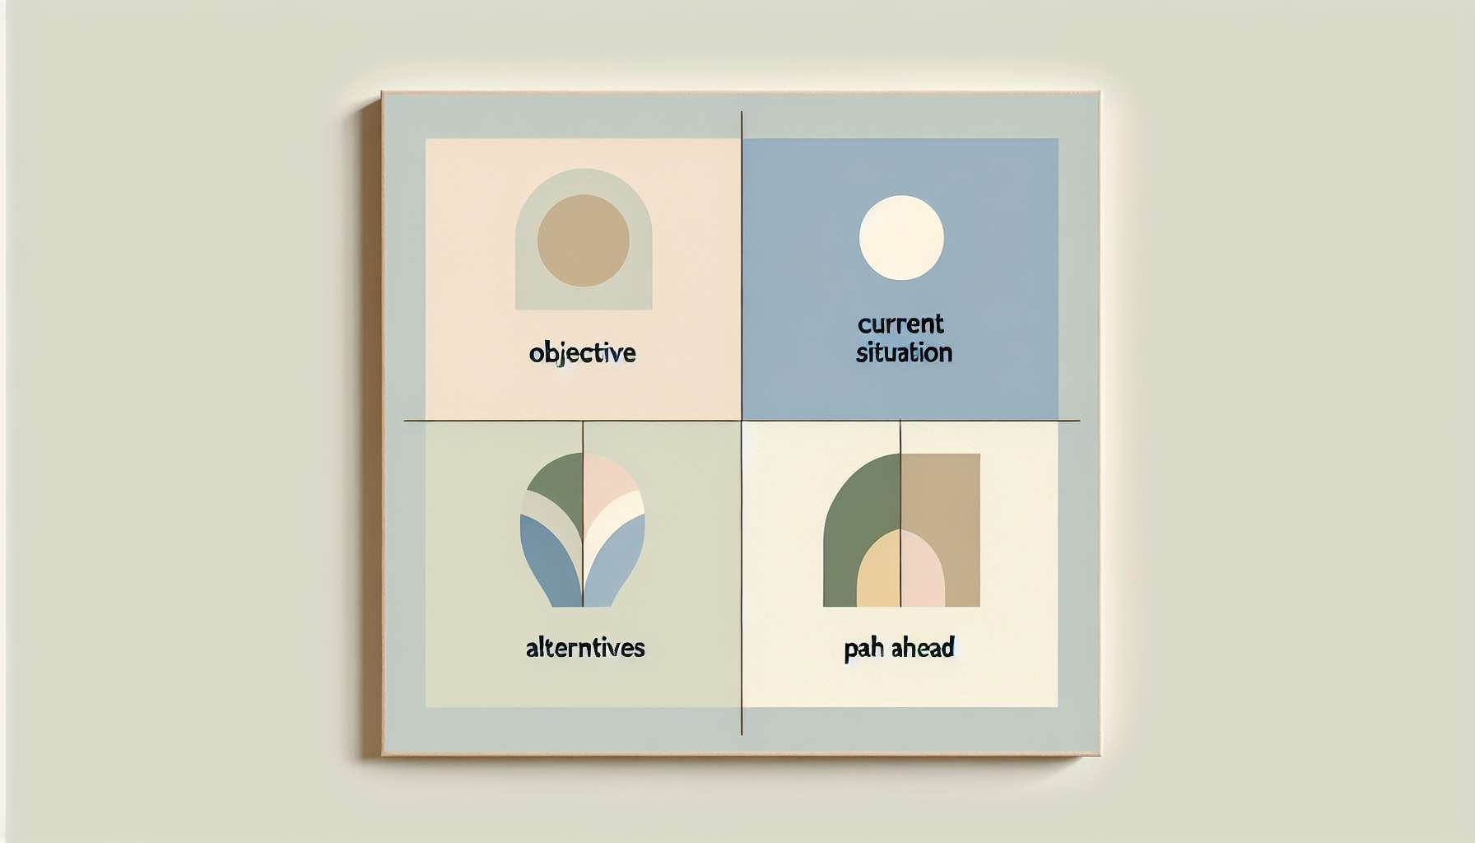

The GROW model is a powerful tool that is widely used in coaching to help clients define and achieve their goals in a structured and efficient way. Developed by Sir John Whitmore, one of the pioneers of coaching, this model provides a clear and practical framework for guiding coaching conversations and facilitating change.  
  
The acronym GROW stands for:   
- Goal: Clarify the specific and measurable goal the client wants to achieve in relation to their Ikigai.  
- Reality: Explore the client's current situation, their resources, and challenges in relation to this goal.  
- Options: Generate a range of possibilities and strategies for achieving the goal, stimulating creativity and reflection.  
- Way forward: Define the concrete actions, steps, and commitment needed to implement the chosen strategy.  
  
By using the GROW model, the Ikigai Coach helps the client transform their vision of the Ikigai into tangible and achievable goals. For example, if the client's Ikigai is "Creating beauty to inspire others", the SMART (Specific, Measurable, Achievable, Realistic, Timely) goal could be "Organize an exhibition of my paintings in a local gallery within the next 6 months and sell at least 5 paintings".  
  
The reality exploration allows for an honest and factual assessment, identifying strengths to build on and obstacles to overcome. The Ikigai Coach uses questioning and feedback techniques seen in previous modules to help the client become aware of their situation with clarity and objectivity.  
  
The option exploration phase is a chance to broaden perspectives and think outside the box. By using creativity and lateral thinking techniques, the Ikigai Coach stimulates the generation of original ideas and encourages the client to consider new possibilities aligned with their Ikigai.  
  
Finally, defining the way forward transforms ideas into concrete commitments. The Ikigai Coach assists the client in prioritizing actions, identifying necessary resources, and anticipating potential obstacles. Planning and tracking tools discussed in previous modules come into practice here to support the realisation of the goal.  
  
The GROW model perfectly integrates with other Ikigai coaching techniques such as metaphors, role-playing, or celebrating successes. It provides a flexible and adaptable structure to guide the client step by step towards achieving their Ikigai, while fostering their autonomy and responsibility in the process.  
  
By mastering the GROW model, the Ikigai Coach has a valuable tool to help clients transform their vision into reality. Regular practice and creativity in using this model allow it to be adapted to each unique situation, and to co-create inspiring and meaningful Ikigai pathways.  
  
Key takeaways:  
  
- The GROW model is a powerful and widely used coaching tool, developed by Sir John Whitmore, to help clients define and achieve their goals in a structured and efficient way.  
  
- GROW stands for: Goal, Reality, Options, and Way forward.  
  
- The Ikigai Coach uses the GROW model to help the client transform their Ikigai vision into tangible and achievable goals, by clarifying the SMART goal, exploring reality, generating creative options, and defining a concrete action plan.  
  
- Reality exploration allows for the identification of strengths and obstacles, while the options exploration phase stimulates creativity and broadens perspectives.  
  
- The action plan transforms ideas into concrete commitments, prioritizing actions, identifying necessary resources, and anticipating potential obstacles.  
  
- The GROW model fits perfectly with other Ikigai coaching techniques, providing a flexible and adaptable structure to guide the client towards achieving their Ikigai, while promoting their autonomy and responsibility.  
  
- Regular practice and creativity in using the GROW model allow the Ikigai Coach to adapt it to each unique situation and co-create inspiring and meaningful Ikigai journeys.