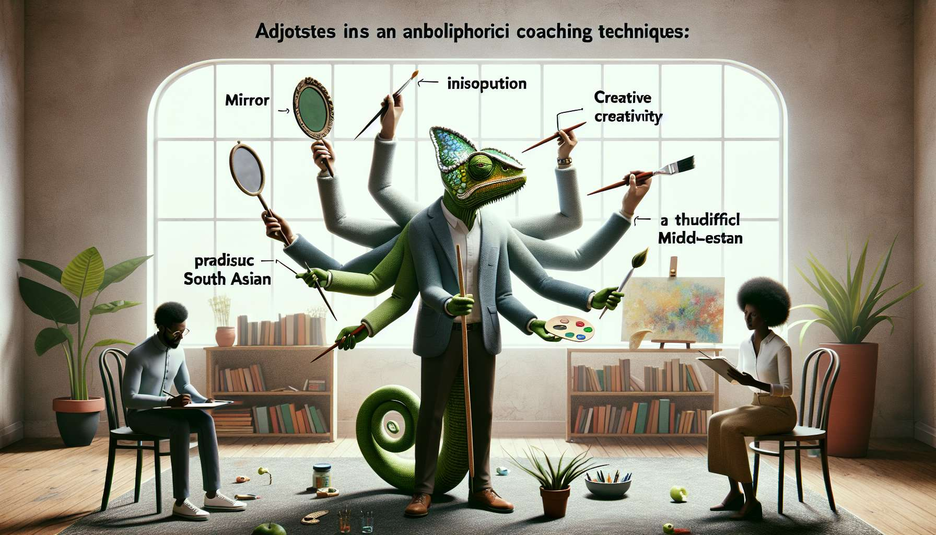

Adaptability and flexibility are vital skills for the Ikigai Coach, allowing continuous adjustment of their approach to the unique needs of each client. In a process as profound and personal as the quest for ikigai, there is no "universal recipe" that would work for everyone. Each client comes with their story, personality, aspirations, and unique challenges. The challenge for the coach is thus to personalize their accompaniment to create the most favorable conditions for each person's fulfillment and self-realization.   
  
Adaptability starts from the exploration and contractualization phase with the client. The Ikigai Coach takes time to understand the context, expectations, and learning style of the client deeply, through a preliminary questionnaire and an in-depth interview. The coach is interested in the client's past accompaniment experiences, communication and feedback preferences, potential constraints... These insights allow to construct a custom journey, with objectives, pace, and modalities adjusted accordingly.  
  
Throughout the sessions, the Ikigai Coach exhibits flexibility in the choice of tools and techniques for accompaniment (module 7 and 8). Depending on the sensitivity and emerging needs of the client, the coach can alternate between more introspective approaches (like inner dialogue or visualization), more creative methods (like collage or mind mapping) or more pragmatic exercises (such as the decision matrix or action plan). This suppleness helps stimulate different forms of intelligence (analytical, emotional, intuitive...) and to maintain a lively and engaging learning dynamic.  
  
Adaptability also comes into play in the posture and relational style of the Ikigai Coach. With more autonomous and assertive clients, the coach will adopt a discreet and facilitating posture, leaving them a lot of latitude in exploration. With others who are more hesitant or in need of benchmarks, the coach can be more directive and reassuring, offering a well-delineated frame. This ability to modulate leadership according to the stages and personality of the client is a strong marker of coaching excellence.  
  
Flexibility is especially crucial in managing unforeseen circumstances and resistances. It is common during coaching for a client to experience a personal or professional crisis, questioning their availability or motivation. The Ikigai Coach then shows flexibility and creativity to adapt to these changes: they may propose to space the sessions, shorten them, or conduct them by phone if necessary. They may also suggest exercises for managing stress and emotions (sub-module 8.6) to help the client navigate these turbulent waters.  
  
Anecdote: During one coaching session, Lucie, a 35-year-old client, realized that she wanted to leave her job to devote herself to her passion for writing. But when it came time to take action, she was seized by fear and doubt, questioning her decision. The Ikigai Coach then showed flexibility by suggesting transforming the planned session into an emotional support session. Through empathic listening and reformulation, the coach helped Lucie to welcome her fears and find a form of inner calm. Then they suggested she redefine an action plan in small steps, making her project seem less intimidating. Lucie appreciated this adaptability, which allowed her to feel understood and supported during this difficult moment.  
  
To develop their adaptability, the Ikigai Coach continually cultivates their curiosity and open-mindedness. By exploring various approaches, training in new tools, and taking an interest in related fields such as psychology and creativity, the coach enriches their "toolbox" and their ability to respond to diverse needs. The practice of meditation and mindfulness (sub-module 8.6) also helps to cultivate flexibility and non-attachment, to accept unforeseen changes with agility. Finally, working on their own resistances to change, through personal work or regular supervision, enables them to accompany the transformation processes of their clients with more fluidity.  
  
By cultivating their adaptability and flexibility, the Ikigai Coach becomes a genuine chameleon of accompaniment, capable of finely adjusting to the singularity of each client. This competency, at the crossroads of empathy, creativity, and relational agility, ensures relevance and efficiency in their practice. It allows co-creating with each client a meaningful and unique ikigai journey, in tune with their pace and profound aspirations. Far from standardized approaches, adaptability opens the way to a decidedly humanistic and personalized accompaniment, serving everyone's fulfilment.  
  
Key takeaways:  
  
- Adaptability and flexibility are essential for the Ikigai Coach to personalize their accompaniment to the unique needs of each client.  
  
- Adaptability starts from the exploration and contracting phase, through a preliminary questionnaire and in-depth interview to understand the client's context, expectations, and learning style.  
  
- The Ikigai Coach shows flexibility in choosing the tools and accompaniment techniques (introspective, creative, pragmatic) to stimulate different forms of intelligence and maintain an engaging learning dynamic.  
  
- Adaptability also applies to the coach's posture and relational style, modulating their leadership according to the client's personality and stages of their journey.  
  
- Flexibility is crucial in managing unforeseen circumstances and resistances, proposing adjustments or specific exercises to help the client navigate difficult moments.  
  
- To develop their adaptability, the Ikigai Coach cultivates their curiosity, open-mindedness, practices mindfulness, and works on their own resistances to change.  
  
- Adaptability allows co-creating with each client a unique and meaningful ikigai journey, serving a humanistic and personalized accompaniment.