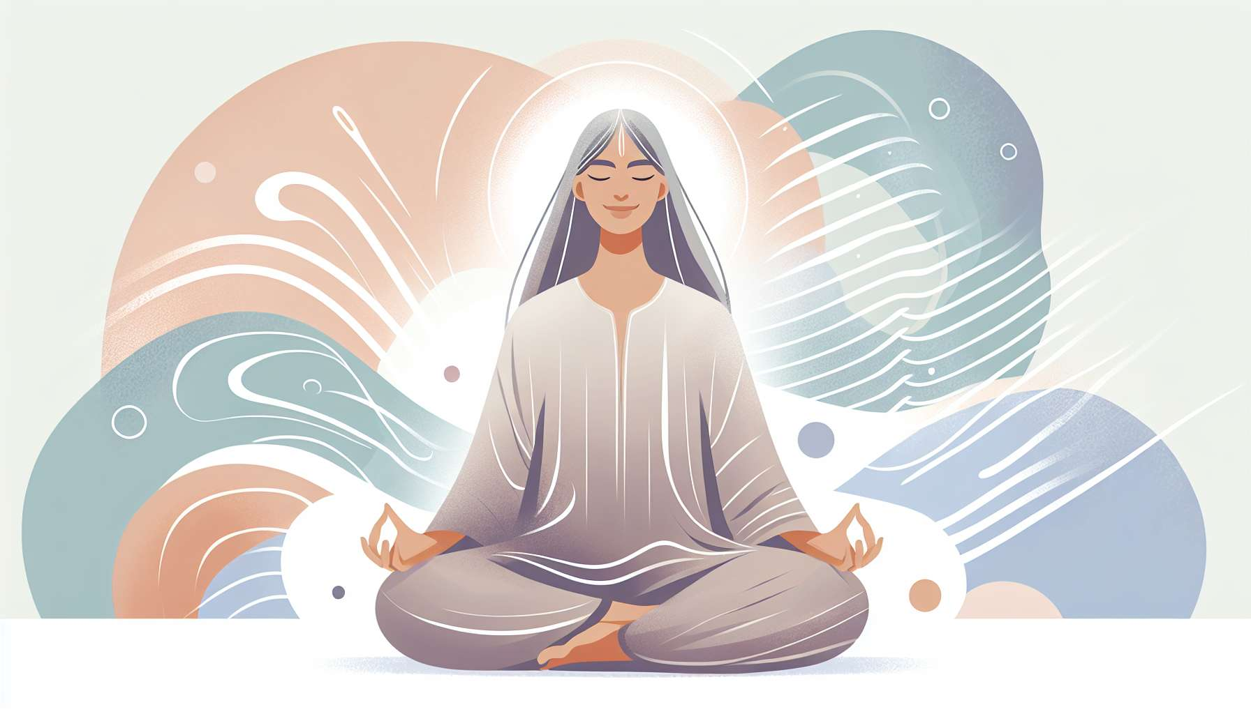

Laughter yoga and meditative laughter techniques are advanced practices of laughter therapy, combining the benefits of laughter with those of yoga and meditation. They allow for a deepening of the laughter experience, anchoring it in bodily consciousness and mindful presence. The aim is to cultivate an inner, subtle and continuous laughter that radiates through the entire being and continues beyond the sessions.  
  
Laughter Yoga, created by Dr. Madan Kataria, involves chaining simulated laughter exercises with deep yogic breathing (pranayama). Typical sessions start with playful warm-ups, then alternate between phases of reasonless laughter and mindful breathing phases. One laughs while sitting, standing, walking, stretching, releasing each part of the body. Yoga postures (asanas) are adapted to encourage the opening of the rib cage and the release of the diaphragm, the seat of laughter.  
  
An example of a sequence is the "laughter in sun salutation": you laugh while performing a series of dynamic movements inspired by the classic sun salutation. You inhale your arms towards the sky while laughing gently, then exhale laughing louder while bending forward, hands towards the ground. You laugh while opening the chest in the cobra pose, then laugh in the downward-facing dog pose... This exercise stretches and tones the whole body, boosts blood and lymphatic circulation while oxygenating and purifying internal organs.  
  
Meditative laughter, on the other hand, is a contemplative practice that invites one to observe and accept the sensations of laughter in the present moment, without seeking to provoke or maintain it. Sitting in silence with eyes closed, one focuses attention on the breath and the subtle movements of laughter in the body. One notices thoughts and emotions that emerge without becoming attached or judging them. Gradually, a gentle and light laughter may arise spontaneously, like an inner vibration, a tremor of pure joy.  
  
A striking example is that of Jean, a hyperactive and stressed senior executive, who discovered meditative laughter during a retreat. Used to laughing in an explosive and loud manner, he was initially unsettled by this introspective approach. By training himself to listen to the laughter within him, like an underground river, he gradually felt a great inner calm. He realized that laughter was not just a simple mechanical reaction, but a deep vital energy, always available within him. This discovery transformed his relationship to laughter and to himself.  
  
Beyond their immediate benefits, laughter yoga and meditative laughter techniques also have long-term effects on overall well-being. They allow for the development of greater self-awareness, greater physical and mental relaxation, and increased emotional resilience. By cultivating laughter rooted in the body and breath, one learns to better manage stress, regulate emotions, and maintain a positive mindset in the face of daily challenges.  
  
During a laughter yoga workshop at a palliative care center, a terminally ill patient testified to the inner peace she found through these practices. Despite pain and anxiety, she managed to replenish herself with a soft and silent laughter, which radiated through her entire being. This meditative laughter helped her to reconnect with life, beauty, and gratitude, beyond illness. She conveyed this luminous serenity to her loved ones and caregivers, creating around her an atmosphere of gentleness and compassion.  
  
It is important to note that these techniques require some training and experienced guidance to reap all the benefits. The facilitator must be a regular practitioner of both laughter yoga and meditation, in order to precisely and integrity convey these tools. They ensure to adapt the exercises to everyone's abilities and needs, in a spirit of kindness and non-judgement. They encourage participants to listen to their own limits and respect their own pace.  
  
In summary, laughter yoga and meditative laughter techniques are true paths of inner transformation through laughter. By unifying the body, breath, and mind in the same joyous vibration, they allow us to experience the spiritual dimension of laughter, beyond mere entertainment. They invite us to discover within ourselves an inexhaustible source of joy, serenity, and vitality, which depends on no external circumstance. Above all, they offer us the opportunity to radiate this laughing and loving presence around us, for the benefit of all beings. For in the end, laughter may be the most beautiful form of prayer and meditation.  
  
Points to remember:  
  
- Laughter yoga and meditative laughter combine the benefits of laughter, yoga, and meditation to deepen the laughter experience and cultivate a subtle and continuous inner laughter.  
  
- Laughter yoga alternates between simulated laughter exercises and deep yogic breathing, adapting yoga postures to facilitate the release of the diaphragm and laughter.  
  
- Meditative laughter is a contemplative practice inviting one to observe and welcome the sensations of laughter in the present moment, without attempting to provoke or maintain it.  
  
- These techniques have immediate and long-term effects on overall well-being, developing self-awareness, physical and mental relaxation, and emotional resilience.  
  
- They require training and experienced guidance to reap all their benefits, with a facilitator who regularly practices these techniques themselves.  
  
- Laughter yoga and meditative laughter are true paths of inner transformation, allowing us to experience the spiritual dimension of laughter and to radiate this joyous and loving presence around us.