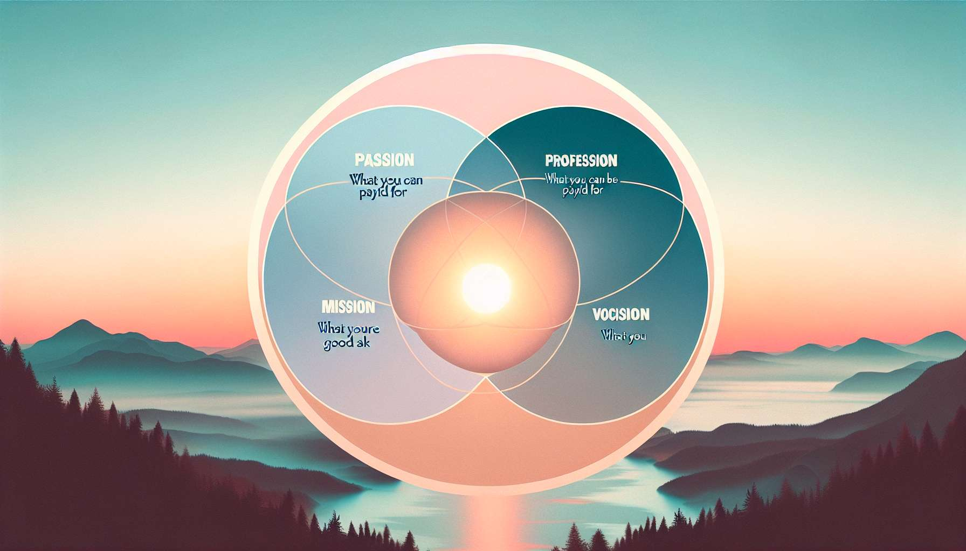

The 4-circle Venn diagram of Ikigai is a powerful visual tool for exploring and identifying one's Ikigai. It allows one to graphically represent the four key dimensions of Ikigai: what one loves, what one is good at, what the world needs, and what one can be paid for. By placing these four dimensions in overlapping circles, one can visualize the areas of convergence and tension between them.  
  
The use of the Venn diagram in Ikigai coaching offers several advantages. Firstly, it helps the client to clarify and articulate their passions, talents, values, and professional aspirations. By reflecting on each circle and identifying the elements that correspond to it, the client becomes aware of what is truly important to them and what gives meaning to their life.  
  
Next, the Venn diagram highlights the overlapping areas between the circles, which represent the areas where the Ikigai can manifest. For example, if a client loves drawing, has a talent for visual communication, notices a need for innovative educational materials and considers setting up their own business, their Ikigai could be at the intersection of these four circles, in the creation of educational visual aids.  
  
The coach can guide the client in exploring each circle by using powerful questions and reflection exercises. For example, for the "what I love" circle, the coach might ask: "What activities bring you pleasure and joy? What makes you lose track of time when you do it?" For the "what I'm good at" circle, the coach might suggest: "What compliments do you often receive about your skills? In what areas do you naturally excel?"  
  
A concrete example of using the Venn diagram in Ikigai coaching is Sophie, a client who worked in finance but did not thrive there. By filling out the four circles, she realized that her passion was writing, that she had a gift for listening and empathy, that she perceived a need for emotional support for people going through difficulties, and that she could consider becoming a writer or coach. This realization allowed her to explore new professional avenues aligned with her Ikigai.  
  
The Venn diagram can also reveal areas of tension or imbalance between the circles. If a client has passions and talents that do not match the world's needs or lucrative opportunities, this can generate frustration or a feeling of inadequacy. The coach can then work with the client to explore ways of reconciling these different aspects, for example by identifying bridges between their skills and the market's needs, or by considering a main professional activity combined with a passion activity on the side.  
  
It is important to note that the Venn diagram is a dynamic and evolving tool. As the coaching progresses and life experiences occur, the client may need to re-evaluate and adjust the contents of each circle. The coach encourages this flexibility and openness, reminding that Ikigai is not a fixed destination but a continuous journey of alignment with oneself and one's environment.  
  
In summary, the 4-circle Venn diagram of Ikigai is a valuable tool for Ikigai coaching. It provides a clear visual representation of the different dimensions of Ikigai, facilitates the client's thinking and exploration, and allows identifying areas of convergence and tension. The coach uses this tool in a flexible and tailored way for each client, assisting them in discovering and actualising their unique Ikigai.  
  
Key takeaways:  
  
- The 4-circle Venn diagram of Ikigai is a powerful visual tool for exploring and identifying one's Ikigai. It graphically represents the four key dimensions: what one loves, what one is good at, what the world needs, and what one can be paid for.  
  
- It helps the client to clarify their passions, talents, values, and professional aspirations by inviting them to reflect on each circle.  
  
- The overlapping areas between the circles represent the areas where Ikigai can manifest. The coach guides the client in this exploration through questions and reflection exercises.  
  
- The diagram can also reveal areas of tension or imbalance between the circles. The coach then accompanies the client in finding ways to reconcile the different aspects.  
  
- It is a dynamic and evolving tool that adapts to the client's journey. Ikigai is seen as a continuous process of alignment with oneself and one's environment.  
  
- The coach uses this tool in a flexible and personalized way to enable the client to discover and actualize their unique Ikigai.