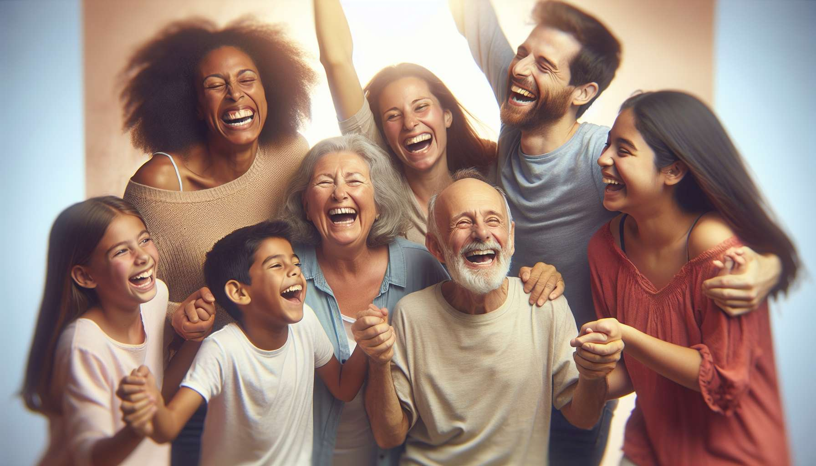

Laughter-in-motion and laughter dance exercises are dynamic and energizing techniques of laughter therapy. They consist of combining laughter with simple body movements, expressive gestures, and movements in space, all set to engaging music. The goal is to release physical and emotional tensions, stimulate creativity and spontaneity, while strengthening the connection with oneself and others.  
  
One of the key principles of these exercises is that movement facilitates and amplifies laughter. By moving, we mobilize the entire body, activate blood and lymphatic circulation, and oxygenate cells. This global activation encourages mental and emotional release, allowing laughter to express itself more freely and intensely. Moreover, movement brings a playful and artistic dimension to laughter by transforming it into a truly joyous and communicative dance.  
  
A classic example is the "circle laughter": participants form a circle and move clockwise while laughing together. They can vary the movements (walk, jump, run...), the directions (forward, backward, to the side...), the levels (high, low, on the ground...), all while maintaining laughter. This exercise creates a positive and inclusive group dynamic, where each individual is carried by the collective energy of laughter. It also develops spatial awareness and psychomotor coordination.  
  
Another powerful technique is the "free laughter dance": to a rhythmic music, participants are invited to let go in a spontaneous and intuitive dance, laughing continuously. They can draw inspiration from various dance styles (salsa, rock, hip-hop, African dance...) or invent their own movements, following their feelings in the moment. The important thing is to laugh while moving, without worrying about technique or aesthetics. This practice liberates inhibitions, boosts self-confidence and creativity, while unleashing repressed emotions.  
  
A striking example is that of Sophie, a shy and reserved fifty-something, who discovered laughter dance during a workshop. At first, she was very uncomfortable and constrained in her movements, fearing other people's judgment. Gradually carried away by the music and the group's laughter, she dared to move more freely and uninhibitedly. She realized that laughter in motion allowed her to express parts of herself previously repressed, such as her sensuality and joy of life. This experience was a real revelation for her, transforming her relationship with her body and others.  
  
Beyond their immediate benefits, laughter-in-motion and laughter dance exercises also have long-term effects on physical and psychological well-being. They allow for the development of better body awareness, greater flexibility, and increased vitality. By laughing and moving regularly, we strengthen our immune system, prevent chronic diseases related to sedentariness, and improve our overall quality of life. Emotionally, these practices help to better manage stress, anxiety, and negative thoughts, promoting a positive and resilient mindset.  
  
During a laughter dance workshop in a retirement home, an 80-year-old resident suffering from Alzheimer's had an extraordinary experience. Usually apathetic and withdrawn, she began to laugh heartily and dance with incredible energy, as if she had found her youth again. This experience moved all the caregivers, who discovered a new facet of her personality. Since then, laughter dance has become a flagship activity of the establishment, bringing joy and life to the residents.  
  
It is important to note that these exercises can be adapted to all audiences and physical conditions. The facilitator makes sure to propose simple and accessible movements that respect each person's abilities. They create a caring and inclusive environment, where everyone feels free to laugh and move in their own way, without judgment or competition. They encourage participants to listen to their bodies and respect their limits while inviting them to explore new possibilities of expression.  
  
In summary, laughter-in-motion and laughter dance exercises are wonderful tools to awaken the body and spirit through laughter. By uniting laughter and movement in a shared celebration of life, they allow us to reconnect with our deep vitality, creativity, and joy of being. They also promote greater harmony between body and mind, aligning breath, gestures, and emotions in the same joyful vibration. And above all, they invite us to express our laughter authentically and embodiedly, making it a real art of living and a dance of the soul.  
  
Key Takeaways:  
  
- Laughter-in-motion and laughter dance exercises combine laughter with body movements to the beat of music, releasing physical and emotional tensions, stimulating creativity, and strengthening the connection with oneself and others.  
  
- Movement facilitates and amplifies laughter by mobilizing the entire body, activating blood and lymphatic circulation, and oxygenating cells, which promotes mental and emotional release.  
  
- "Circle laughter" and "free laughter dance" are examples of exercises that create a positive group dynamic, develop spatial awareness, psychomotor coordination, boost self-confidence and creativity.  
  
- These exercises have beneficial long-term effects on physical and psychological well-being, such as better body awareness, increased flexibility and vitality, strengthened immune system, and better management of stress and negative emotions.  
  
- They can be adapted to all audiences and physical conditions, in a caring and inclusive environment that respects each person's abilities.  
  
- By uniting laughter and movement, these exercises enable the reconnection to one's deep vitality, creativity, and joy of being, promoting greater harmony between body and mind.