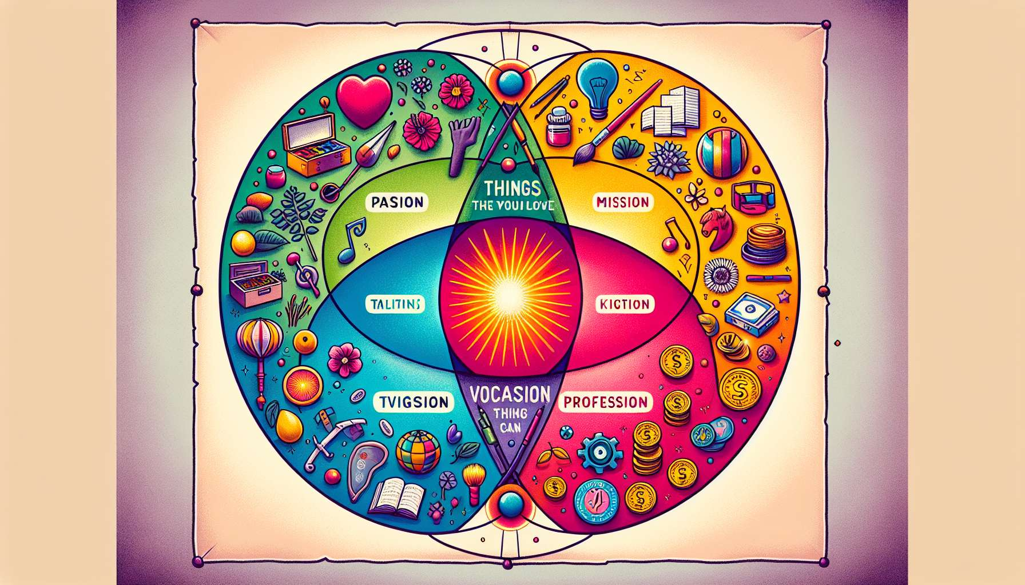

The concept of Ikigai is based on four interconnected circles, which represent the different dimensions of our lives and our personal fulfilment. These four circles are: what we love to do (passion), what we are good at (vocation), what the world needs (mission) and what we can be paid for (profession).  
  
The first circle, passion, refers to all activities and areas that bring us pleasure, joy, and enthusiasm. These are the things we do out of pure interest, without expecting any external reward. This may include hobbies, sports, arts, travel, or any other interest that inspires and motivates us.  
  
The second circle, vocation, represents our natural talents, acquired skills, and personal strengths. It is what we are good at, where we have particular ease, skill and expertise. Our vocation can be related to intellectual, creative, relational, manual skills or character traits such as patience, rigor, or empathy.  
  
The third circle, the mission, embodies our desire to contribute positively to the world around us. It is what gives us a broader sense of purpose, beyond our own personal satisfaction. Our mission might be to solve a societal problem, to help a community, to protect the environment, to transmit knowledge, or any other cause that is close to our hearts.  
  
The fourth circle, profession, symbolizes the economic and material dimension of our lives. It is what we can be paid for, in exchange for our time, energy and skills. Our profession can be a salaried job, independent work, a business or a project that generates income and enables us to meet our needs.  
  
Ikigai is found at the intersection of these four circles, when we align our passions, talents, sense of service, and ability to make a living from it. It is the ideal convergence point, where we feel fulfilled, useful, and valued in what we do. Achieving this balance is not always easy as it often implies choices, compromises and a good deal of creativity.  
  
Take the example of Anna, who is passionate about cooking and has a knack for creating new recipes. She dreams of opening a restaurant offering healthy and tasty dishes, made from local and seasonal products. Her Ikigai could be to become a chef and entrepreneur, creating a friendly place that promotes responsible eating and educates customers about the importance of quality food. Thus, she would combine her passion for gastronomy, her culinary talent, her desire to contribute to people's health, and her ambition to make it her profession.  
  
Of course, finding one’s Ikigai is not a linear or final process. It requires introspection, experimentation, and adaptation over time. Our passions, skills, aspirations and opportunities can evolve with our experiences and encounters. The key is to stay in tune with oneself, to cultivate curiosity and not be afraid to adjust one’s course when necessary.  
  
The four circles of Ikigai invite us to adopt a holistic vision of our existence, taking into account all facets of our being. They encourage us to nurture our passions, to develop our talents, to serve others and to find a way to earn a living from it decently. It is an inspiring model for building a rich life of meaning, accomplishment, and joy, in harmony with oneself and the world around us.  
  
Key takeaways:  
  
- Ikigai is based on four interconnected circles: passion (what we love), vocation (what we are good at), mission (what the world needs) and profession (what we can be paid for).  
  
- Ikigai is found at the intersection of these four circles, when one aligns their passions, talents, sense of service, and ability to make a living from it.  
  
- Finding one’s Ikigai requires introspection, experimentation, and adaptation over time, staying in tune with oneself and cultivating curiosity.  
  
- The four circles of Ikigai invite us to adopt a holistic vision of our existence, taking into account all facets of our being.  
  
- Ikigai is an inspiring model for building a rich life of meaning, accomplishment, and joy, in harmony with oneself and the world around us.