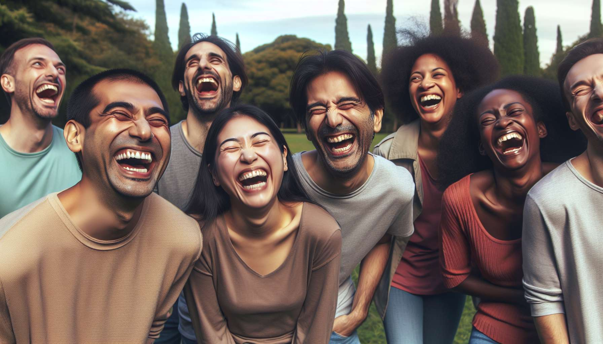

Laughter is a complex and multiform phenomenon, which can take different forms and intensities depending on the situations and individuals. In the context of laughter therapy, it is important to distinguish the main types of laughter and their specific characteristics, in order to use them appropriately and effectively.  
  
The first type of laughter is spontaneous laughter, which occurs naturally and uncontrollably in reaction to a funny or enjoyable stimulus. This is the laughter of a child playing, of an adult hearing a funny joke or sharing a moment of complicity with friends. Spontaneous laughter is often intense, explosive, and relatively brief. It is accompanied by characteristic physiological changes, such as an increase in heart and respiratory rate, a contraction of facial and abdominal muscles, and tear secretion. Spontaneous laughter is considered the most authentic and therapeutically beneficial laughter, as it reflects a genuine positive emotional state.  
  
The second type of laughter is simulated laughter, which is deliberately provoked and controlled by will. This is the fundamental principle of laughter therapy, where participants are invited to mechanically reproduce the sound and movements of laughter, without necessarily feeling a joyous emotion. Initially, simulated laughter may seem artificial and forced, but it quickly tends to transform into authentic laughter through a contagion and entrainment effect. Simulated laughter has the advantage of being accessible to everyone, even those who are down or hesitant to guffaw spontaneously. It also extends the physiological and psychological effects of laughter beyond a few seconds.  
  
The third type of laughter is stimulated laughter, which is triggered by specific techniques aimed at arousing a state of excitement and euphoria conducive to laughter. Examples include tickling games, frantic dances, joyful songs, collective cries, or deep breathing exercises. These techniques act as "triggers" for laughter by modifying the physical and emotional state of participants. Stimulated laughter is often used as a warm-up or transition between simulated laughter exercises, in order to maintain a positive and energizing dynamic.  
  
Beyond these three main types, there are numerous variations and nuances in the expression of laughter, which reflect the diversity of human emotions and situations. Some laughs are quiet and muffled, others are loud and resounding. Some laughs are communicative and benevolent, others are sarcastic or mocking. Some laughter releases deep tensions and inhibitions, like cathartic laughter that sometimes occurs in moments of great emotional intensity. Other laughter reflects a feeling of embarrassment, shyness, or politeness.  
  
In the practice of laughter therapy, it is essential to adapt to the sensitivity and experience of each participant, respecting their boundaries and preferences. Some people are naturally more expressive and extroverted, while others are more reserved and modest in their way of laughing. The aim is not to impose a uniform style of laughter, but to create favorable conditions for the emergence of authentic and liberating laughter that respects each person's personality.  
  
In summary, knowledge of the different types of laughter and their characteristics allows the laughter therapist to adapt their interventions and guide participants more finely and effectively. By alternating moments of spontaneous, simulated, and stimulated laughter, varying the intensities and nuances of laughter, it is possible to create a rich and progressive experience that maximizes the therapeutic benefits of laughter while respecting the pace and sensitivity of each individual.  
  
Key points:  
  
1. Spontaneous laughter is the most authentic and therapeutically beneficial, reflecting a genuine positive emotional state.  
  
2. Simulated laughter is accessible to everyone and extends the physiological and psychological effects of laughter beyond a few seconds.  
  
3. Stimulated laughter is triggered by specific techniques aiming to provoke a state of excitement and euphoria conducive to laughter, and is often used as a warm-up or transition between simulated laughter exercises.  
  
4. There are many variations and nuances in the expression of laughter, reflecting the diversity of human emotions and situations.  
  
5. Cathartic laughter sometimes occurs in moments of great emotional intensity and releases deep tensions and inhibitions.  
  
6. In the practice of laughter therapy, it is essential to adapt to the sensitivity and experience of each participant, respecting their boundaries and preferences.  
  
7. The goal of laughter therapy is to create favorable conditions for the emergence of authentic and liberating laughter that respects each person's personality.  
  
8. By alternating moments of spontaneous, simulated, and stimulated laughter, and varying the intensities and nuances of laughter, it is possible to create a rich and progressive experience, maximizing the therapeutic benefits of laughter while respecting the pace and sensitivity of each individual.