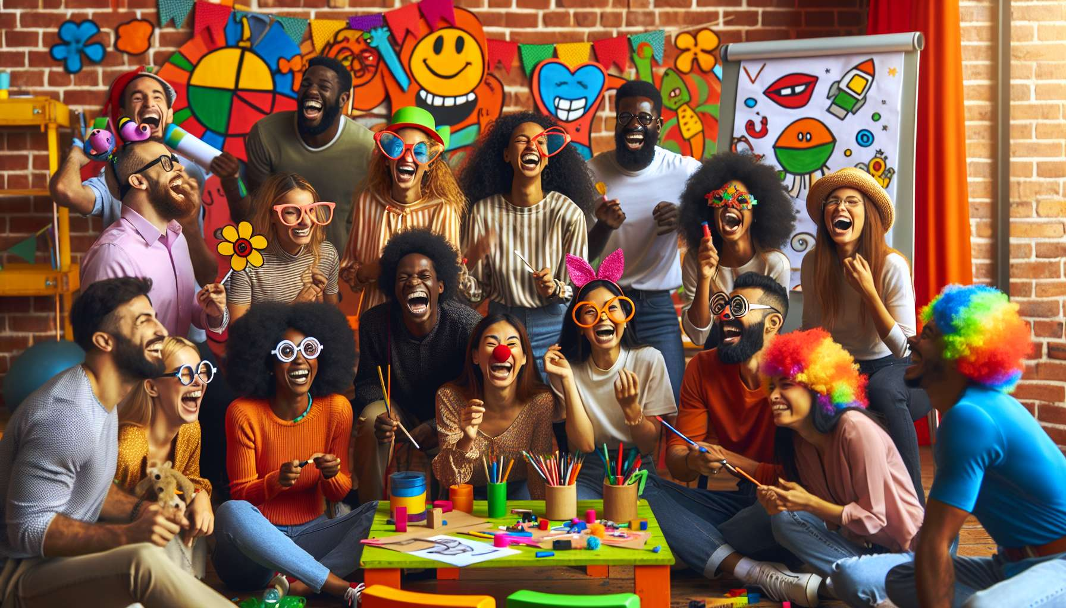

Laughter and problem-solving techniques are powerful tools in laughter therapy, allowing us to tackle challenges and difficult situations with a creative, light-hearted and resilient approach. They involve using humor and laughter as levers to take a step back, change perspective, and find innovative solutions to the problems encountered.  
  
The key principle of these techniques is that laughter and humor are valuable resources for defusing situations, putting issues into perspective and reducing stress related to problems. By approaching a difficulty with an amused and offbeat attitude, we create a space of freedom and play that encourages mental flexibility, creativity and openness to new possibilities. Laughter acts as a "cognitive and emotional lubricant" that streamlines thought and relationships, and allows us to break free from dead ends and blocks.  
  
A classic example is the technique of "humorous reframing": when faced with a problem, we practice reformulating it in an exaggerated, absurd or offbeat way, until it becomes laughable and loses its negative emotional charge. We can thus transform "I am useless at maths, I am going to fail my exam" into "My neurons are on a number strike, they demand more jokes and puns to get back to work!". This new humorous perspective opens up paths for creative solutions, such as revising in a fun way with maths games and riddles.  
  
Another effective technique is "humorous brainstorming": to solve a problem, we generate as many outlandish, exaggerated and offbeat ideas as possible, without any self-censorship. The objective is to let go, stimulate divergent thinking, and enjoy the outlandish proposals that emerge. In a second step, these quirky ideas can be analysed to extract original and relevant solution paths. For example, to resolve a conflict with a colleague, we could imagine absurd scenarios like "invite them to a pillow fight in a pink tutu" or "serenade them with an apology song in gibberish". By pushing humor to the extreme, we diffuse the situation and open up to more creative and peaceful resolution methods.  
  
A striking example is that of Sophie, a young entrepreneur facing financial difficulties in her business. Stressed and discouraged, she attended a laughter and problem-solving workshop. In a "laughter superhero" exercise, she imagined her financial problem as a dastardly bandit she had to fight with her laughter superpower. By visualizing this epic battle in an exaggerated and goofy way, she became aware of her inner resources and her ability to overcome this challenge with resilience and creativity. This experience gave her the courage to seek innovative solutions, like proposing offbeat and humorous offers to attract new customers.  
  
In addition to their immediate benefits, laughter and problem-solving techniques also have long-term effects on personal and professional development. They help strengthen emotional intelligence, self-confidence and the ability to cope with life's ups and downs with flexibility and optimism. By cultivating a positive and humorous attitude towards challenges, we develop greater resilience and a greater ability to bounce back after failures. We also learn to communicate in a more constructive and soothing way, using humor to defuse tensions and promote cooperation.  
  
During a workplace stress management training session, a group of managers experienced the "funny problem court". Each person presented a professional problem in an exaggerated and offbeat way, as if they were pleading before a jury of clowns. The other participants, disguised as quirky judges, proposed absurd and humorous sentences to solve these problems, like "sentence the manager to a week of community service in a circus". By defusing their difficulties with laughter, the managers gained distance and found creative solution paths, such as implementing "funny meetings" to diffuse conflicts in their teams.  
  
It is important to note that these techniques require a caring and safe environment to be fully effective. The facilitator makes sure to create an atmosphere of trust and respect, where everyone can express their problems without fear of being judged. They give clear and progressive instructions to tame laughter and humor as resolution tools, adapting to everyone's comfort and ease level. They encourage creativity and value all ideas, even the wildest ones, to stimulate free expression and audacity. They also ensure that humor remains kind and constructive, serving to solve problems rather than mock or escape from them.  
  
In summary, laughter and problem-solving techniques are formidable allies to face life's challenges with lightness and creativity. By daring to laugh at our problems and transform them through humor, we give ourselves permission to be imperfect, to seek original solutions and to cultivate a more serene and confident view of the future. We realize that laughter is an inexhaustible resource for transcending obstacles, connecting with others, and savoring life in all its richness. And above all, we discover in ourselves an unsuspected strength: that of turning every difficulty into an opportunity to grow, learn and marvel, with a smile and laughter as compasses. Because at the end, laughing at our problems is already surpassing them and opening up to new possibilities.  
  
Key Points to Remember:  
  
- Laughter and problem-solving techniques use humor and laughter to approach challenges with creativity and resilience.  
  
- Laughter defuses situations, reduces stress and promotes mental flexibility and creativity when faced with problems.  
  
- Humorous reframing involves reformulating a problem in an offbeat way until it becomes laughable, opening up new perspectives.  
  
- Humorous brainstorming generates outlandish and exaggerated ideas to stimulate divergent thinking and find original solutions.  
  
- These techniques strengthen emotional intelligence, self-confidence and the ability to bounce back from failures.  
  
- They require a caring and safe environment, where the facilitator encourages creativity and values all ideas.  
  
- Laughing at our problems allows us to surpass them, open up to new possibilities and cultivate a more serene view of the future.