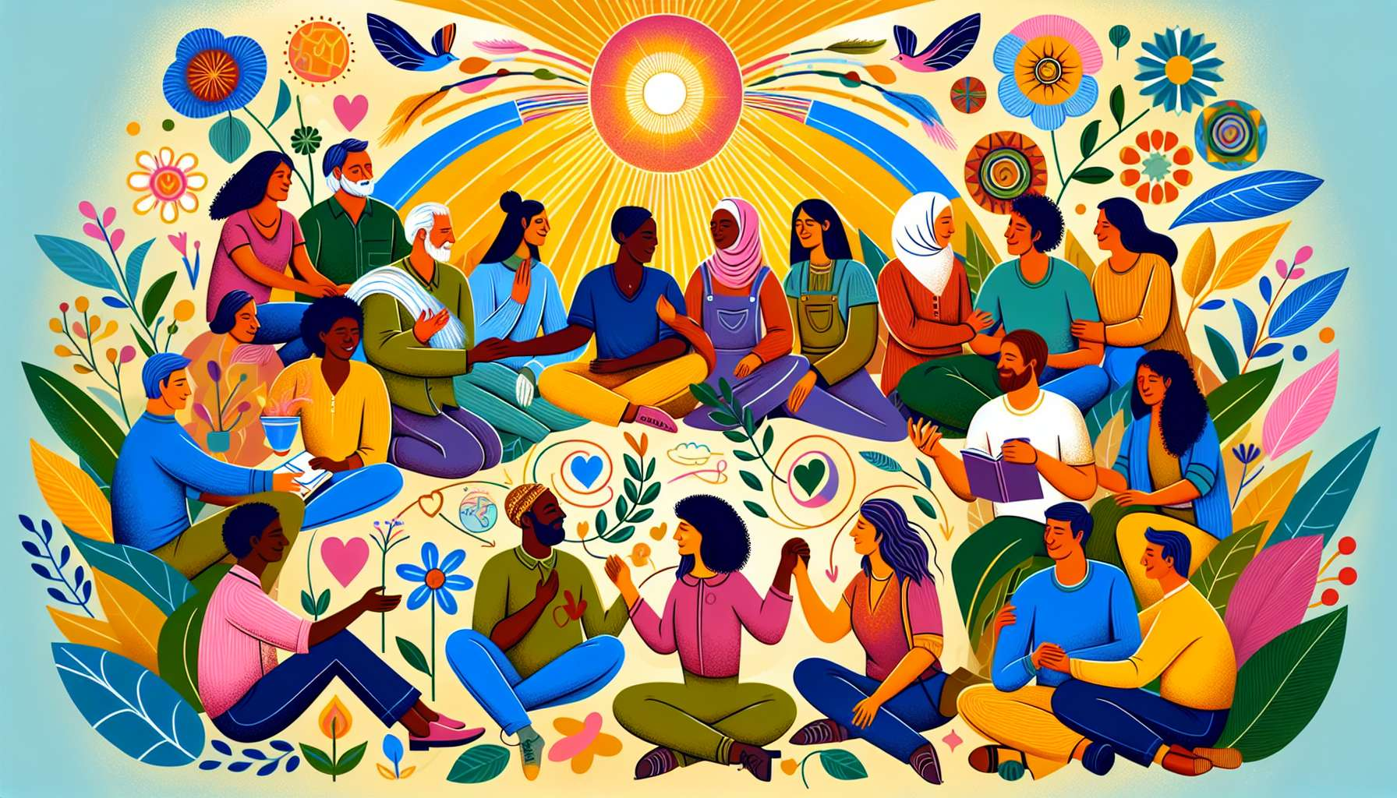

Ikigai is a powerful catalyst for developing more authentic and fulfilling interpersonal relationships. Indeed, when aligned with our reason for being and living coherently with our values, we naturally attract people who resonate with our energy and world view. We thereby create a virtuous circle where we surround ourselves with inspiring, kind and supportive individuals, who encourage us to be fully ourselves and to pursue our deepest aspirations.  
  
Imagine a person whose Ikigai is to "create connections and harmony within their community". By engaging in collaborative projects, organizing unifying events, and taking the time to listen to and understand others, they will develop meaningful and close-knit relationships. Their authenticity and kind attention will inspire trust and provoke deep exchanges, beyond superficialities. Each interaction will become an opportunity to nurture their Ikigai and create connections that mutually lift and enrich.  
  
Ikigai also invites us to communicate in a more integrated and transparent way. By being clear with our intentions, needs, and boundaries, we learn to express them with assertiveness and respect. We free ourselves from the unspoken, power plays, and manipulations that often pollute relationships. We dare to be vulnerable, share our doubts and dreams, ask for help when we need it... This honesty creates an atmosphere of trust and emotional security that allows everyone to feel welcomed in their entirety.  
  
For example, imagine a manager whose Ikigai is to "reveal the potential of their collaborators". By communicating clearly about their vision, expectations, and feedback, while listening to the needs and ideas of their team, they will create a virtuous dynamic of accountability and cooperation. Each person will feel considered, valued in their unique contribution, and motivated to give the best of themselves. The relationships will be based on mutual respect, a desire to grow together rather than on power struggles or competition.  
  
Another valuable contribution of Ikigai is to help us manage conflicts in a more constructive way. By being centered on our values and our reason for being, we learn not to react impulsively under the sway of emotion, but to take a step back to understand the needs and fears underlying each position. We seek creative solutions that honor the essence of each one, rather than wanting to be right at all costs. We develop our empathy and our ability to put ourselves in the other's shoes, to find common ground beyond differences.  
  
Ikigai also encourages us to cultivate nourishing and inspiring relationships, which pull us up and push us to excel. By being clear with our life mission, we become more selective in our interactions, we choose to surround ourselves with people who share our values and inspire us with their example. We learn to protect ourselves from toxic or energy-draining relationships, which take us away from our Ikigai and prevent us from expressing our full potential. We create virtuous circles where everyone encourages each other to dare, to create, to contribute to the world in a unique way.  
  
Of course, living one's Ikigai does not protect from relational difficulties and misunderstandings. But it gives us a compass to navigate these challenges with more serenity and wisdom. By remaining faithful to our values and our reason for being, we learn to set our boundaries with kindness, not to be diverted from our path by others' expectations. We develop our assertiveness and our ability to communicate our deep needs, to create relationships where everyone can be authentic and fully flourish.  
  
By integrating the concept of Ikigai into our way of interacting with others, we thereby develop precious relational skills, based on authenticity, empathy, and cooperation. We learn to create links that feed both our reason for being and those of others, in mutual enrichment. Our relationships then become a fertile ground for expressing our full potential and contributing together to a more harmonious and inspiring world.  
  
Takeaways:  
  
- Ikigai fosters authentic and fulfilling relationships by attracting people who resonate with our values and world view.  
  
- In aligning with our reason for being, we create a virtuous circle of inspiring and compassionate interactions that encourage us to be ourselves.  
  
- Ikigai encourages us to communicate in an integrated and transparent manner, by clearly expressing our intentions, needs, and boundaries. This creates an atmosphere of trust and emotional security.  
  
- Centered on our values, we manage conflicts in a more constructive way, with empathy and creativity, striving towards solutions that honor each person.  
  
- Ikigai prompts us to cultivate nourishing relationships that inspire and elevate us, while protecting us from toxic relationships that distract from our life mission.  
  
- While Ikigai doesn't prevent all relational difficulties, it gives us a compass to face them serenely, with assertiveness and kindness.  
  
- By integrating Ikigai into our interactions, we develop relational skills based on authenticity, empathy, and cooperation, creating connections that mutually nourish our reason for being.