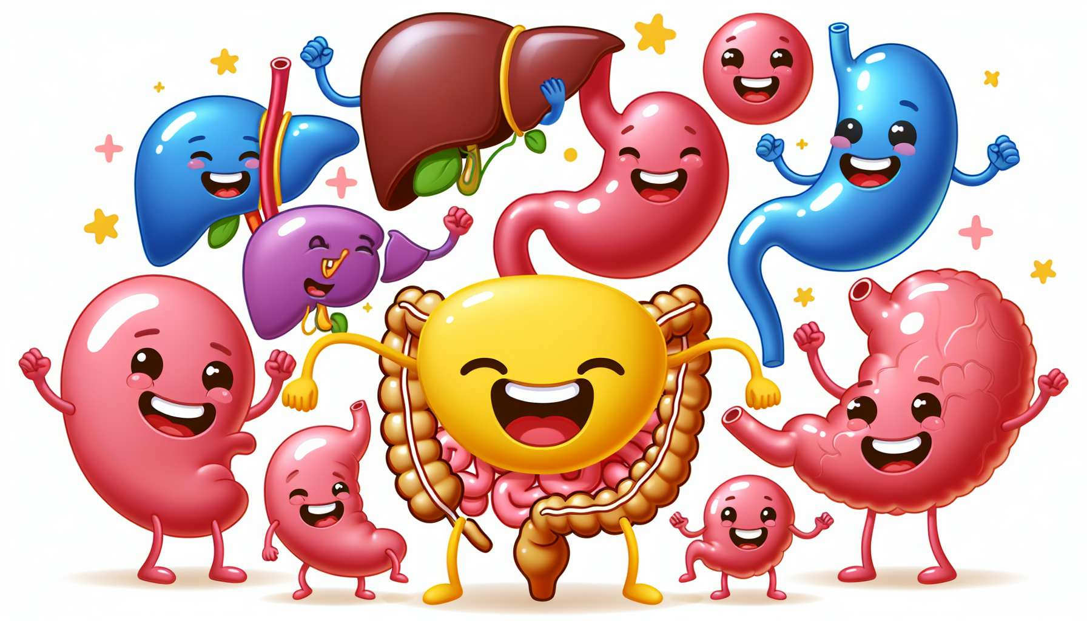

Laughter is a real internal massage for our digestive system. When we laugh, our diaphragm and our abdominal muscles contract jerkily, thus creating a real kneading of our digestive organs. These repeated movements stimulate peristalsis, i.e., the rhythmic contractions that allow the progression of food in the digestive tract. Regular laughter therefore promotes a more fluid and efficient digestion, thus reducing the risks of constipation and bloating.   
  
But laughter does more than just mechanically stimulate our digestion. It also acts on the secretion of digestive juices, such as saliva, pancreatic enzymes and bile. When we laugh, our mouth salivates more, thus facilitating the mastication and swallowing of food. This extra saliva also helps neutralise gastric acidity and protect the lining of the oesophagus. At the level of the pancreas, laughter stimulates the release of digestive enzymes such as lipase, amylase and trypsin, which efficiently break down fats, sugars and proteins. As for bile, produced by the liver and stored in the gallbladder, it is better released under the effects of laughter jolts, thus aiding fat digestion.  
  
Laughter also has a positive impact on our intestinal microbiota, the ecosystem of billions of bacteria that populate our gut. Studies have shown that positive emotions such as joy and amusement promote the growth of "good" bacteria in our gut, such as Lactobacilli and Bifidobacteria. These beneficial bacteria strengthen our intestinal barrier, thus preventing leaks and inflammation. They also produce protective substances like butyrate, which nourishes the cells of the intestinal mucosa. Regularly laughing therefore helps maintain a balanced and diverse intestinal microbiota, the real keystone of our digestive health.  
  
But the digestive benefits of laughter don't end there. Laughter is also a great stress reliever for our stomach. When we are stressed, our sympathetic nervous system is activated, putting our body in "fight or flight" mode. This stress response inhibits digestion, causing spasms, inflammation and abdominal pain. Laughter, stimulating the parasympathetic nervous system, helps counterbalance these negative effects of stress. It promotes the relaxation of the smooth muscles of the intestine, thus reducing cramps and bloating. Laughing also allows you to release accumulated tensions in the diaphragm and stomach, bringing a feeling of relaxation and abdominal wellbeing.  
  
Laughter is particularly beneficial for people suffering from functional bowel disorders like irritable bowel syndrome (IBS). These disorders, often linked to stress and anxiety, are characterised by abdominal pain, bloating and alternation of diarrhoea and constipation. Studies have shown that regular practice of laughter yoga significantly reduces IBS symptoms, thus improving patients' quality of life. Laughter acts as a real gentle and natural therapy to soothe irritable bowels.  
  
Finally, laughter can help us better manage digestive disorders related to our diet. When we eat too fast, without chewing well, or when we consume difficult-to-digest foods, our digestive system can become overloaded and painful. In these uncomfortable moments, the reflex often is to tense up and stress, which worsens symptoms. Trying to laugh, even a little bit, helps relax the stomach and intestine, thus facilitating the digestion process. It's as if laughter helps us "digest" our food mistakes with more lightness and kindness towards ourselves.  
  
Integrating more laughter into our daily life is thus a wonderful way to pamper our digestive system. Whether by practicing laughter yoga exercises, watching comedies or sharing joyful meals with loved ones, each burst of laughter is a gift to our stomach. So, let's not hesitate to laugh out loud, it's the best natural remedy for a happy digestion!  
  
Takeaways:  
  
- Laughter acts as an internal massage for the digestive system, stimulating peristalsis and promoting more fluid and efficient digestion.  
  
- Laughing increases the secretion of digestive juices such as saliva, pancreatic enzymes and bile, thus aiding food digestion.  
  
- Positive emotions associated with laughter promote the growth of "good" bacteria in the gut, contributing to a balanced and diverse intestinal microbiota.  
  
- Laughter, by stimulating the parasympathetic nervous system, counteracts the negative effects of stress on digestion, reducing cramps, bloating and inflammations.  
  
- Regular practice of laughter yoga can help reduce symptoms of irritable bowel syndrome (IBS).  
  
- Laughing can help better manage digestive disorders related to improper diet by relaxing the stomach and intestine.  
  
- Incorporating more laughter into our daily life, whether through specific exercises or joyful shared moments, is beneficial for our digestive health.