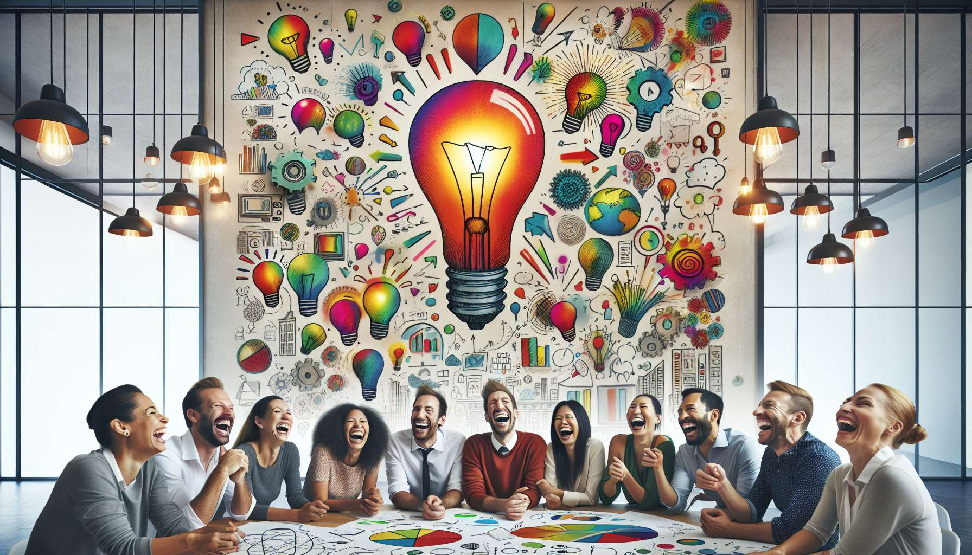

Laughter is a tremendous catalyst for creativity and a valuable problem-solving tool. When we laugh, we stimulate our divergent thinking, we broaden our field of possibilities. Laughter helps us to think outside the box, to break our usual patterns of thought, to explore new perspectives. By freeing us from our inhibitions and fear of judgement, laughter encourages creative risk-taking, the daring to imagine original and innovative solutions.  
  
Neuroscience research has shown that laughter activates specific areas of our brain related to creativity and problem-solving, such as the prefrontal cortex and the ventral tegmental area. These regions are involved in the processes of associative thinking, mental imagery, cognitive flexibility. Regular laughter helps us to develop and strengthen these creative skills, to boost our "artistic brain".  
  
Laughter is also a powerful tool for defusing tension that helps us to step back from challenges and problematic situations. By laughing at a difficulty, we reduce the negative emotional charge associated with it, we reduce our stress and anxiety. This allows us to approach the problem with more lightness and serenity, to clear our mind to search for solutions. As Albert Einstein said: "Creativity is intelligence having fun".  
  
Laughing in a group even further amplifies these positive effects on creativity and problem-solving. Shared laughter creates a positive collective dynamic, an environment of trust and kindness conducive to the emergence of new ideas. By laughing together, we mutually stimulate our imagination, we bounce our proposals off each other, we jointly build unexpected solutions. Laughter fosters team cohesion and creative synergy, it helps us to collaborate smoothly and joyfully.  
  
In the professional world, many innovative companies have understood the value of integrating laughter and humor into their management practices and creative processes. At Google, for example, workshops of "Laughter Yoga" are regularly organized to stimulate the creativity of teams. At Southwest Airlines, known for the quality of its customer service, humor is an integral part of the company culture and is encouraged at all levels.  
  
Thus, by cultivating laughter in our lives and in our organizations, we unleash our creative potential, we stimulate our ability to innovate and to find original solutions to our challenges. We develop an agile and positive mental posture, a fresh and playful perspective on the world around us. As Pablo Picasso summed it up: "Art washes our soul from the dust of everyday life". So, let laughter wash our soul and fertilize our creative genius!  
  
Key takeaways:  
  
- Laughter is a catalyst for creativity and a valuable tool for problem-solving. It stimulates divergent thinking, broadens the realm of possibility and aids in breaking free from routine thought patterns.  
  
- By liberating from inhibitions and fear of judgment, laughter encourages creative risk-taking and the daring to envision innovative solutions.  
  
- Neuroscience research demonstrates that laughter activates areas of our brain related to creativity, like the prefrontal cortex and ventral tegmental area, participating in associative thinking, mental imagery, and cognitive flexibility.  
  
- Laughter aids in managing and gaining some distance from challenges by reducing the negative emotional charge and stress, thus promoting a lighter, more serene approach to problem-solving.  
  
- Group laughter amplifies the positive effects on creativity through the positive collective dynamic and climate of trust it induces. Laughter encourages team cohesion and cooperative solution-building.  
  
- Numerous innovative companies incorporate laughter and humor into their managerial practices and creative processes to stimulate creative potential and the capacity for innovation.  
  
- Cultivating laughter develops an agile and positive mental stance, a fresh, playful outlook conducive to creativity and original problem-solving.