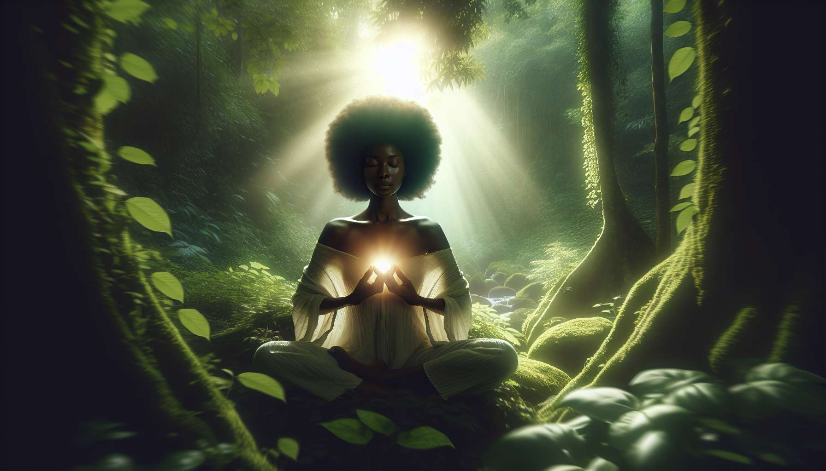

Ikigai and physical and mental health are closely linked, as our overall well-being depends on the harmony between our body, our mind and our soul. Finding your Ikigai is to discover a reason for living that drives us, motivates us and gives meaning to our existence. It's about cultivating a positive, resilient and fulfilled mindset, which radiates over our health and vitality.  
  
Numerous scientific studies have shown the benefits of Ikigai on physical and mental health. People who have found their Ikigai tend to live longer, be less stressed, less depressed and less subject to chronic diseases. They also have a better self-esteem, greater life satisfaction and a stronger sense of belonging to their community.  
  
For example, a study conducted on the inhabitants of Okinawa, a Japanese island renowned for the longevity of its inhabitants, revealed that those who had a strong Ikigai lived on average seven years longer than others. They were also less likely to develop cardiovascular diseases, cancers or dementia. Their secret? A simple, active and meaningful life, rooted in values of sharing, mutual aid and respect for nature.  
  
Ikigai acts as a protective shield against stress and anxiety, by giving us a sense of control and purpose in our lives. When we are engaged in activities that we are passionate about and that challenge us positively, we release well-being hormones like dopamine, serotonin and endorphin. These neurotransmitters strengthen our immune system, regulate our mood and provide us with a sensation of joy and fulfillment.  
  
Cultivating your Ikigai also means taking care of your body and mind daily, through healthy and fulfilling life habits. It's about engaging in regular physical activity that makes us feel good, like walking, yoga or dancing. It's about eating healthy and tasty food, rich in fruits, vegetables and whole foods. It's about sleeping sufficiently and restoratively, respecting our biological rhythms. It's also about taking regular breaks in nature, to recharge and reconnect with the essentials.  
  
Beyond lifestyle habits, Ikigai invites us to cultivate a positive mental and emotional hygiene, based on gratitude, benevolence and resilience. This is learning to accept and manage our emotions with gentleness and discernment, without judging or repressing them. It is about developing an encouraging and compassionate inner speech, that supports us in difficult moments. It's also about cultivating nourishing and benevolent relationships, that provide us with support, joy and inspiration.  
  
Finding one's Ikigai also means being able to listen to the messages from one's body and heart, to adjust one's lifestyle accordingly. It's about being attentive to signs of fatigue, stress or discomfort, and taking necessary measures to remedy them. It's about daring to say no to toxic activities and relationships, that drain us of our energy and zest for life. It's about knowing how to ask for help when we need it, from our loved ones or health professionals.  
  
Ikigai encourages us to adopt a holistic and preventive vision of our health, by taking care of ourselves in all our dimensions - physical, mental, emotional and spiritual. It invites us to become the actors of our well-being, by making conscious and benevolent choices for ourselves and others. It reminds us that our health is our most precious asset, and that it's our responsibility to cherish and preserve it.  
  
Cultivating your Ikigai is therefore giving yourself the means to live a long, healthy and fulfilled life, in accordance with your values and deep aspirations. It's about radiating vitality, joy and presence, and inspiring others to do the same. It's about becoming a model of global health, embodying the balance between body, heart and mind. By finding our Ikigai, we become the artisans of our own health, and we contribute to creating a healthier and happier world for all.  
  
Key points to remember:  
  
- Ikigai and physical and mental health are closely linked. Finding your Ikigai contributes to a global and sustainable well-being.  
  
- People with a strong Ikigai tend to live longer, be less stressed and depressed, and have better self-esteem and life satisfaction.  
  
- Ikigai acts as a shield against stress and anxiety by giving meaning and purpose to life. It stimulates the release of well-being hormones.  
  
- Cultivating your Ikigai implies taking care of your body and mind daily through healthy lifestyle habits: physical activity, balanced diet, restorative sleep, contact with nature.  
  
- Ikigai invites to develop positive mental and emotional hygiene based on gratitude, kindness, resilience and nourishing relationships.  
  
- Finding your Ikigai requires being attentive to your body and heart to adjust your lifestyle and dare to say no to toxic activities and relationships.  
  
- Ikigai promotes a holistic and preventive approach to health, taking into account physical, mental, emotional and spiritual dimensions.  
  
- By cultivating your Ikigai, you become an actor of your well-being and an inspiring model of global health, thus contributing to a healthier and happier world.