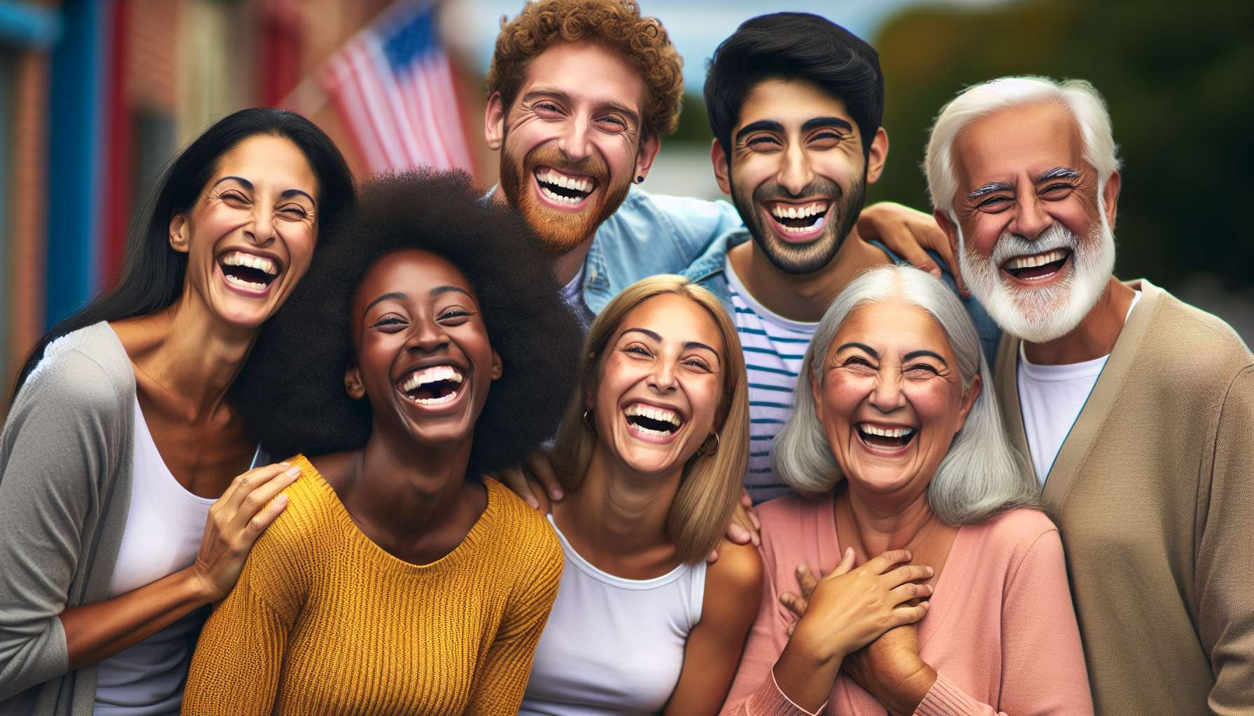

Individual differences in the perception and expression of laughter are a fascinating and complex aspect of the psychology of laughter. Every individual possesses a unique sensitivity and reactivity to humor, shaped by a combination of biological, psychological, and social factors.  
  
At the biological level, studies have shown that certain genetic and neurochemical factors can influence the predisposition to laughter and humor. For example, variations in the genes involved in the regulation of serotonin and dopamine, two key neurotransmitters in the reward and pleasure circuit, could explain why some people laugh more easily and frequently than others.   
  
A study conducted on twins has thus revealed that the sense of humor and propensity for laughter were more similar in monozygotic twins than in dizygotic twins, suggesting a significant genetic influence.  
  
At the psychological level, personality plays an important role in the perception and expression of laughter. Traits such as extraversion, openness to experience, and emotional stability are often associated with a more developed sense of humor and increased reactivity to laughter. Extraverted and emotionally stable people tend to laugh more often and more intensively, appreciate humorous situations more, and use humor as a tool for communication and stress management.  
  
A shy and introverted colleague may thus have a sense of humor just as developed as an extroverted and jovial colleague, but will tend to express it in a more subtle and discreet manner, for example through wordplay or ironic remarks.  
  
Humor styles also vary among individuals, reflecting differences in preferences, values, and communication strategies. Some people appreciate absurd and quirky humor, others prefer intellectual and satirical humor, while others are more sensitive to compassionate and inclusive humor. These differences in style can influence how laughter is perceived and expressed, as well as situations in which it is deemed appropriate or not to laugh.  
  
During a work meeting, a colleague may thus appreciate a subtle and dry-witted joke about a project, while another will find this joke inappropriate and will prefer to lighten the atmosphere with a fun and innocent anecdote.  
  
At the social and cultural level, norms, values, and expectations related to laughter and humor can vary greatly from one group to another. What is considered funny and acceptable in one context can be perceived as inappropriate or offensive in another. Social codes and rituals related to laughter, such as laughing at certain moments of a conversation or sharing a collective fit of laughter, are deeply influenced by culture and education.  
  
Understanding and respecting these cultural differences is essential to adapt one's practice of laughter according to audiences and intervention contexts.  
  
In certain Asian countries like Japan, for instance, laughter is often used to mask discomfort or embarrassment in delicate social situations, where in other cultures it might be interpreted as a lack of seriousness or respect.  
  
Personal history and life experiences also play a role in the perception and expression of laughter. A person who grew up in an environment where laughter was encouraged and valued will often find it easier to laugh and appreciate humor than a person who evolved in a more strict and serious environment. Traumas and difficulties encountered can also influence the relationship with laughter, either making it more difficult and painful, or conversely, strengthening it as a mechanism of resilience and coping.  
  
As a Laughter Therapist, it is crucial to be aware of these individual differences and create a supportive and inclusive space where each person can laugh in their own way, without judgement or comparison.  
  
During a laughter workshop in a heterogeneous group, some participants may break into loud laughter from the first exercises, while others will need more time to relax and let go. Some will laugh heartily at a joke, while others might smile discreetly. The important thing is to value and encourage each form of expression, by adapting the exercises and feedback to the needs and preferences of each.  
  
Cultivating sensitivity and openness to the diversity of laughter allows the creation of richer, more nuanced, and respectful interventions of each person's uniqueness. By celebrating differences rather than trying to erase them, the Laughter Therapist can assist everyone in developing a more authentic and fulfilling relationship with their own laughter and that of others.  
  
Key Takeaways:  
  
- Individual differences in the perception and expression of laughter are influenced by biological, psychological, and social factors.  
  
- At the biological level, genetic and neurochemical variations can explain the differences in predisposition to laughter and humor.  
  
- At the psychological level, personality (extraversion, openness, emotional stability) and humor styles influence how laughter is perceived and expressed.  
  
- At the social and cultural level, norms, values, and expectations related to laughter vary among groups. It's important to understand and respect these cultural differences.  
  
- Personal history and life experiences also play a role in the individual's relationship with laughter.  
  
- As a Laughter Therapist, it's crucial to be aware of these individual differences and create a supportive and inclusive space where each person can laugh in their own way.  
  
- Cultivating a sensitivity and openness to the diversity of laughter allows the creation of richer, nuanced, and respectful interventions of each person's uniqueness.