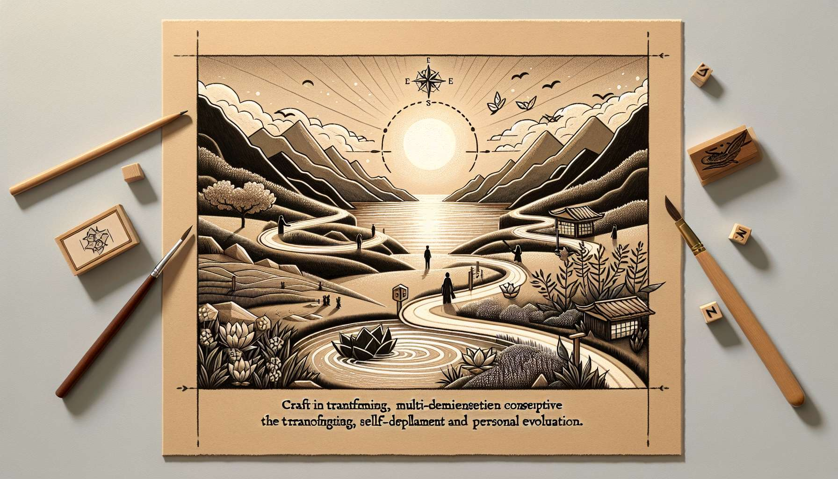

The discovery and realization of one's Ikigai are deeply personal and unique processes, which cannot be reduced to a universal formula or ready-made recipes. However, many myths and misconceptions circulate around this concept, potentially creating confusion and unrealistic expectations. By identifying and deconstructing them, we can approach our quest for Ikigai with greater clarity, authenticity, and compassion for ourselves.  
  
One of the most widespread myths is that Ikigai would be something fixed and immutable, that one would discover once and for all at a certain point in our life. This static vision of Ikigai can generate pressure and anxiety, as if we absolutely must find our "true" reason for being or risk missing out on our existence. In reality, Ikigai is a dynamic and evolving process, transforming over time according to our experiences, encounters, and personal journey. Our reason for being can take different forms and express itself in various areas of our life, at different stages of our journey.   
  
Take the example of Sophie, a young woman passionate about art and creativity. Early in her professional life, her Ikigai was expressed through her work as a graphic designer, where she could unleash her imagination and create inspiring visuals. A few years later, upon becoming a mother, she felt the need to pass on her passion to her children and discovered a new facet of her Ikigai in art education. Simultaneously, she began to volunteer at an organization promoting art therapy, thus giving her life's purpose a broader and more altruistic dimension. Sophie's Ikigai has continuously evolved and enriched over time, adapting to her aspirations and life circumstances.  
  
Another tenacious myth is that Ikigai is limited to the professional sphere, as if our reason for being necessarily had to be embodied in our work. While some people's jobs are indeed the main vehicle for their Ikigai, this is not a universal rule. Our reason for being can be expressed in various areas, such as our relationships, hobbies, volunteer commitments, or personal development. The essential thing is to find balance and coherence between these different facets, so that our Ikigai permeates our whole life.  
  
Consider the journey of Jean, a talented computer scientist who long believed that his Ikigai had to be realized exclusively in his career. Despite his professional success, he increasingly felt a void and dissatisfaction. By exploring other aspects of his personality, he discovered a passion for climbing and mountain sports. By pursuing this path, he found a new meaning in life, a source of self-overcoming and connection with nature that deeply nourished his being. Today, Jean has found a fulfilling balance between his job as a computer scientist and his regular practice of climbing, which are two complementary facets of his Ikigai.  
  
Another misconception is that Ikigai should necessarily be linked to a grand plan, a noble cause, or a significant impact on the world. While some indeed find their life's purpose through altruistic commitment or significant societal contribution, this is not an absolute requirement. Our Ikigai can perfectly be embodied in simple actions, moments of presence and connection, or practices that nourish us inwardly. The key is to find what brings meaning and joy to our existence, on our scale and according to our deepest aspirations.  
  
Take the example of Anna, a retiree who long searched for her reason for existence in large humanitarian or charitable projects. In discussions with her Ikigai Coach, she realized that her deep need was simply to weave links and bring a touch of gentleness to her daily life. She then began to cultivate a small shared garden in her neighborhood, organize cooking workshops for her neighbors, and knit outfits for newborns in her community. These simple, concrete actions, rooted in her daily routine, became the heart of her Ikigai, giving her a deep sense of contribution and satisfaction.  
  
Finally, a last myth to deconstruct is that discovering one's Ikigai would be a final destination, an accomplishment after which we would be permanently fulfilled and aligned with our life's purpose. In reality, finding one's Ikigai is a continuous journey, marked by questions, adjustments, and renewals. Throughout our lives, our aspirations, priorities, and circumstances evolve, inviting us to revisit and deepen our reason for being. Ikigai is not a fixed state to achieve, but an inner compass guiding us to ever more authenticity, meaning, and fulfillment.  
  
Consider the journey of Pierre, an entrepreneur who built a thriving business in the field of sustainable development. For many years, his Ikigai was equated with the success of his project, giving him a sense of purpose and accomplishment. Yet, when reaching a turning point in his life, he felt the need to reevaluate his priorities and reconnect with his deep aspirations. By exploring new horizons, he discovered a passion for teaching and sharing knowledge, leading him to redirect his Ikigai. Today, Pierre divides his time between managing his company and conducting training sessions on responsible entrepreneurship, thus nourishing various facets of his life's purpose.  
  
By deconstructing these myths and misconceptions about Ikigai, we can approach our quest for meaning with greater flexibility, compassion, and openness. Instead of looking for a magical formula or definitive answer, we can embrace the evolving and multidimensional nature of our life's purpose. By cultivating an attitude of exploration, inner listening, and ongoing adjustment, we can make our Ikigai an inspiring companion, guiding us towards greater alignment, fulfillment, and contribution to the world around us.  
  
Key Takeaways:  
  
1. Ikigai is a personal and unique process that cannot be reduced to a universal formula.  
  
2. Ikigai is not fixed and immutable, but dynamic and evolving, transforming throughout personal experiences and journeys.  
  
3. Ikigai is not limited to the professional sphere but can be expressed in multiple areas of life (relationships, hobbies, volunteer commitments, personal development).  
  
4. Ikigai does not necessarily have to relate to a grand project or significant world impact but can embody in simple actions and moments of presence and connection.  
  
5. Discovering one's Ikigai is not a final destination but a continuous path marked by questions, adjustments, and renewals.  
  
6. Deconstructing myths and misconceptions about Ikigai can make the search for its meaning more flexible, compassionate, and open.  
  
7. Cultivating an attitude of exploration, inner listening, and ongoing adjustment can make Ikigai an inspiring companion guiding towards alignment, fulfillment, and contribution to the world.