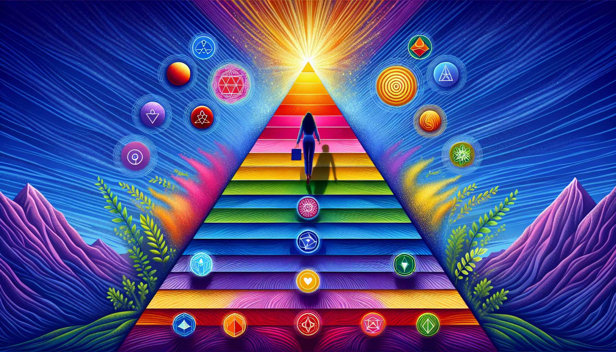

Ikigai and Maslow's hierarchy of needs share a common vision of human fulfillment, where self-actualization occupies a central place. Abraham Maslow, humanist psychologist, proposed a theory of human motivation based on a hierarchy of needs, from basic physiological needs to higher self-actualization needs. This hierarchy offers relevant insights into the quest for Ikigai and the journey towards a meaningful life.  
  
According to Maslow, human needs are organized into five levels, each higher level can only be reached when the lower levels are met. At the base of the pyramid are physiological needs (food, water, sleep), followed by safety needs (protection, stability), belonging and love needs (relationships, affection), esteem needs (recognition, respect), and finally, at the top, the needs for self-actualization (achievement, creativity). This hierarchical view suggests that the quest for Ikigai, which belongs to the higher needs, can only fully express itself when fundamental needs are met.  
  
The concept of Ikigai aligns with the top of Maslow's pyramid, the need for self-actualization. Maslow defined self-actualization as the actualization of one's full potential, expressing one's talents and creativity in an activity that gives meaning to one's life. This is precisely what Ikigai aim for: finding one's reason for being, one's deep-seated calling, by aligning one's passions, skills and contribution to the world. Ikigai encourages us to connect with what fundamentally drives us and to unleash our unique potential in the service of a cause that transcends us.  
  
A striking example of the convergence between Maslow's hierarchy of needs and Ikigai is that of Naoki Higashida, a Japanese author with severe autism. Despite the immense challenges he faces, Higashida has found in writing a means of expression and self-realization. His book "The Reason I Jump" has achieved international success and has helped change perceptions of autism. Despite the obstacles related to his condition, Higashida has been able to reach the higher levels of Maslow's pyramid through his Ikigai, his passion for writing and his desire to raise awareness about autism. His journey illustrates how, even in the most difficult circumstances, the quest for Ikigai can transcend basic needs and pave the way for a meaningful life.  
  
Maslow's hierarchy of needs also suggests that the realization of Ikigai is a gradual process, which develops over time and through experiences. Before fully devoting oneself to one's purpose, it is often necessary to meet fundamental security, belonging and esteem needs. These needs create a foundation of stability and self-confidence, essential for embarking on a existential quest as deep as the Ikigai. By cultivating nurturing relationships, developing a sense of competence and gaining the respect of those around us, we acquire the inner resources needed to embark on discovering and realizing our Ikigai.  
  
However, Maslow's hierarchy of needs is not an immutable law, and the quest for Ikigai can sometimes transcend the established order. Some people, driven by a devouring passion or a sharp sense of their mission, may devote themselves to their Ikigai even before fully satisfying their basic needs. This is the case for many artists, entrepreneurs or activists who, driven by their vision, are willing to make sacrifices to achieve their dream. In these situations, Ikigai acts as a powerful engine, capable of sublimating shortcomings and giving meaning to adversity.  
  
Maslow's hierarchy of needs also highlights the importance of the social and cultural environment in the realization of Ikigai. The needs for belonging, esteem and self-actualization are deeply influenced by the context in which the individual evolves. A society that values individual expression, creativity and community contribution will create a fertile ground for the flowering of Ikigai. Conversely, a repressive, competitive or indifferent environment can stifle deep aspirations and make the quest for meaning more difficult. The realization of Ikigai thus appears as a shared responsibility, involving both the individual in their personal journey and society in its duty to create the conditions conducive to the fulfillment of everyone.  
  
The thought of Maslow and the philosophy of Ikigai call us to a holistic vision of human fulfillment, where the realization of self occupies a central place. They remind us that the quest for meaning and fullness is a gradual process, which is built on the basis of meeting fundamental needs. By cultivating a nurturing environment, developing our unique potential and engaging in activities that deeply resonate with us, we create the conditions favorable to the emergence and realization of our Ikigai. This quest, both personal and universal, calls us to transcend the limits of the hierarchy to embrace a life rich in meaning, passion and contribution to the world around us.  
   
Key points to remember:  
  
1. Ikigai and Maslow's hierarchy of needs share a common vision of human fulfillment, where self-realization takes center stage.  
   
2. According to Maslow, human needs are organized into five hierarchical levels, and the quest for Ikigai falls under the higher self-actualization needs.  
   
3. Ikigai corresponds to the actualization of one's full potential and the expression of one's talents in an activity that gives meaning to life.  
   
4. The realization of Ikigai is a gradual process that builds on the satisfaction of fundamental security, belonging and esteem needs.  
   
5. However, the quest for Ikigai can sometimes transcend the established order of the hierarchy of needs, when a devouring passion or a sharp sense of one's mission drive the individual.  
   
6. The social and cultural environment plays a crucial role in the realization of Ikigai, by creating conducive or unfavorable conditions for individual fulfillment.  
   
7. The thought of Maslow and the philosophy of Ikigai invite a holistic vision of human fulfillment, where the quest for meaning and fullness is both a personal and universal process.