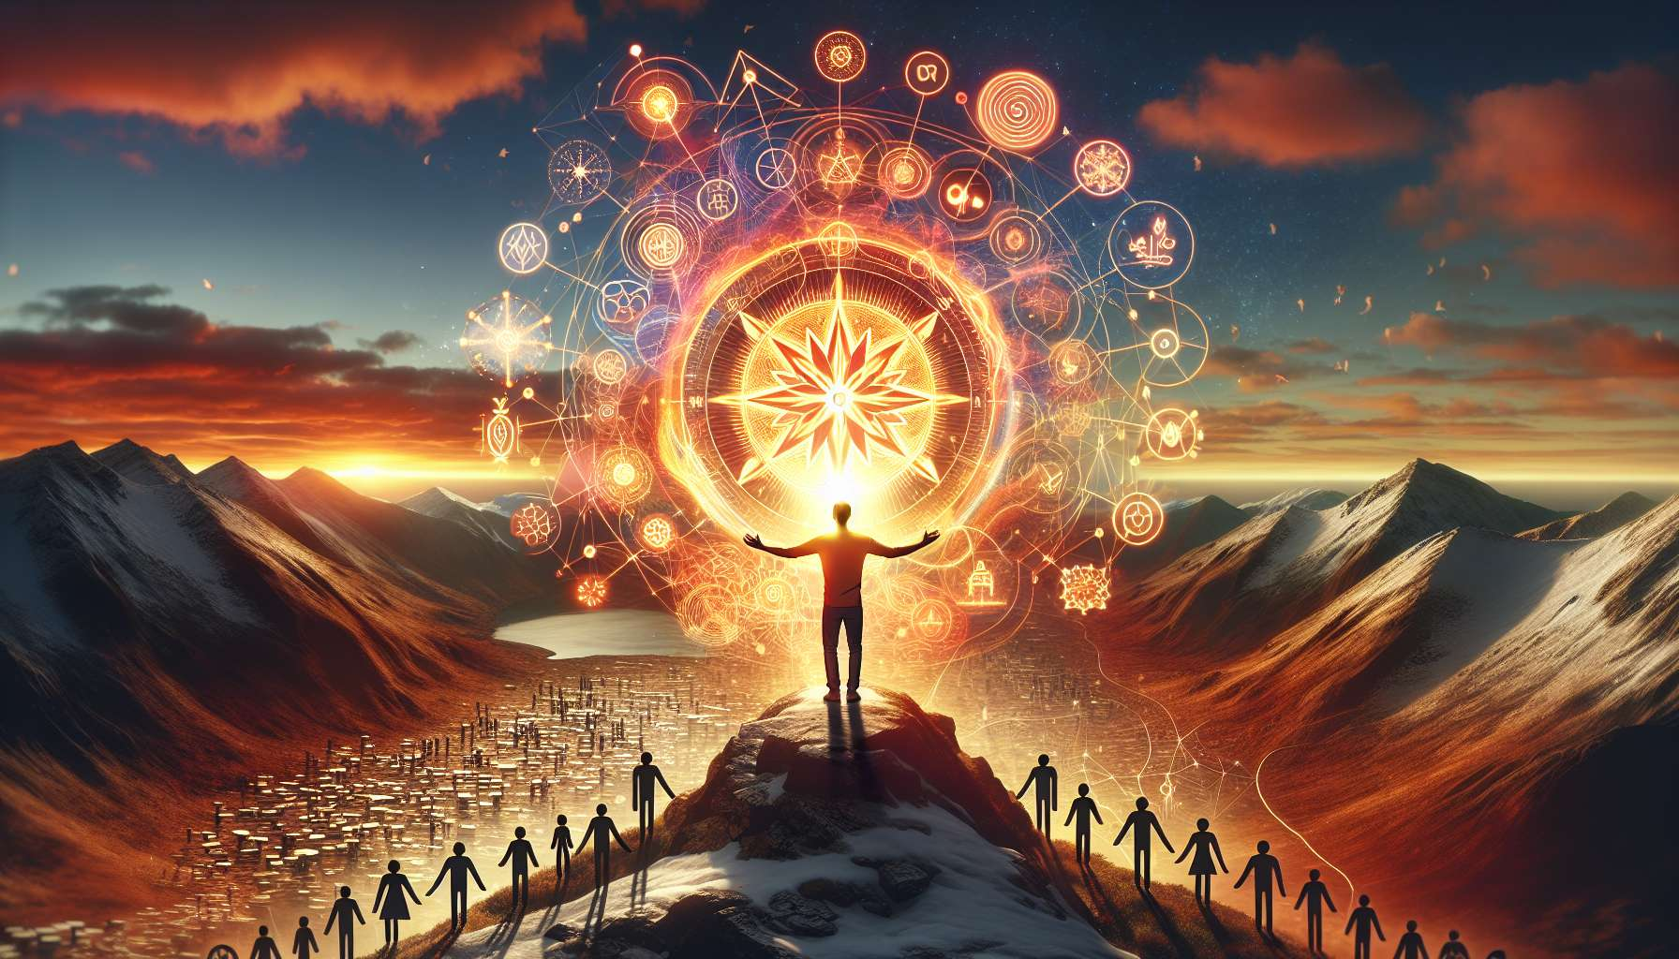

Ikigai is a powerful engine for continuous learning and personal development. Indeed, when we are aligned with our purpose and live authentically, we naturally develop a thirst for knowledge and an insatiable curiosity for everything that can nourish our life's mission. We approach learning not as a constraint or an obligation, but as an exciting path of growth, enabling us to increasingly deploy our unique potential.  
  
Imagine a person whose Ikigai is to "create innovative solutions to preserve the environment". By fully engaging in this path, they will feel the need to continually deepen their knowledge in ecology, green technology, sustainable entrepreneurship... Every book, every conference, every exchange with experts will be an opportunity to enrich their vision and find new avenues to fulfill their mission. Their Ikigai will be like a compass that continuously orients and stimulates their learning.  
  
Ikigai also invites us to cultivate a growth mindset, where each difficulty is approached as an opportunity to learn and grow. Instead of getting discouraged in the face of an obstacle or failure, we seek to learn lessons to improve and bounce back. We thereby develop a form of intellectual resilience, where we are able to question our certainties, explore new perspectives and constantly adapt.  
  
Take for example a researcher whose Ikigai is to "unravel the mysteries of the brain to cure neurodegenerative diseases". Faced with an experiment that does not yield the expected results, they will not give up, but instead will seek to understand what did not work, formulate new hypotheses, and conceive more relevant protocols. This permanent learner mindset will allow them to gradually progress towards their goal, transforming each deadlock into a stepping stone towards discovery.  
  
Another valuable contribution of Ikigai is to help us learn in a holistic and interconnected way. By being centered on our purpose, we realize that each field of knowledge, even if seemingly distant, can potentially nourish and enrich our mission. We thus develop a form of systemic thinking, where we seek to connect knowledge, bridge disciplines for innovation, and find unique solutions.  
  
Let's imagine an artist whose Ikigai is to "create works that awaken ecological consciousness". By opening up to fields as diverse as biology, philosophy, anthropology, or spirituality, they will feed their creativity and give a new depth to their art. For example, they can draw inspiration from natural forms to design organic sculptures, use vegetable pigments for their paintings, integrate reflections on the place of humans in nature... Their Ikigai will be like a prism that brings coherence and meaning to all their learning.  
  
Ikigai finally invites us to learn in community, surrounding ourselves with people who share our thirst for knowledge and our will to contribute to the world. By joining or creating learning circles around our life's mission, we inspire each other, share our discoveries and questions, and help each other when faced with difficulties. These co-learning relationships multiply our motivation and our capacity to quickly progress towards our goals.  
  
Take the example of an entrepreneur whose Ikigai is to "revolutionize education through digital technology". By participating in online communities of educational innovators, attending EdTech conferences, collaborating with educational science researchers, they will continuously stimulate their reflection and enrich their toolkit. They can confront their ideas, discover new approaches, find partners to develop their projects... Their Ikigai will be like a magnet attracting knowledge and resourceful people to realize their vision.  
  
By cultivating continuous learning through the prism of Ikigai, we thus transform personal development into an art of living that is fascinating and meaningful. Every new knowledge, every skill acquired becomes another brick in the edifice of our unique accomplishment and contribution. Our thirst for learning then merges with our thirst for living fully, becoming the best version of ourselves to let our light shine in the world.  
  
Key takeaways:  
  
- Ikigai stimulates continuous learning by nourishing a thirst for knowledge and a curiosity in connection with our life's mission.  
  
- It encourages us to see learning as an exciting path of growth rather than a constraint.  
  
- Ikigai fosters a growth mindset where difficulties are opportunities to learn and improve.  
   
- It promotes intellectual resilience to question one's beliefs and adapt constantly.  
   
- By being centered on our purpose, Ikigai encourages a holistic learning that connects different domains of knowledge.  
  
- It stimulates systemic thinking to bridge disciplines and foster innovation.  
  
- Ikigai urges us to learn in community, surrounding ourselves with people who share our thirst for growth and contribution.  
  
- These co-learning relationships multiply our motivation and progress towards our goals.  
   
- With Ikigai, personal development becomes an exciting and meaningful art of living.