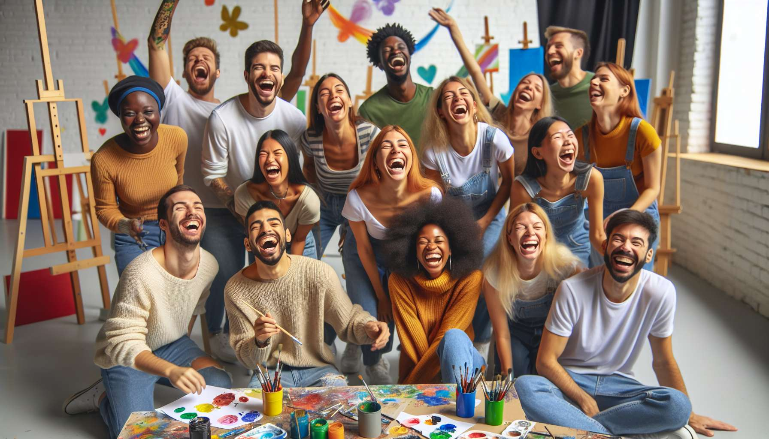

Laughter and creativity exercises are stimulating and original techniques of laughter therapy. They consist of combining laughter with creative and imaginative activities, with the aim of releasing the inventive and humorous potential of each person. The goal is to develop divergent thinking, spontaneity and the ability to see things from a new, offset and amusing angle.  
  
The key principle of these exercises is that creativity and laughter mutually enrich each other. When we laugh, we relax, let go, and open ourselves to new perspectives. This playful and relaxed state of mind promotes the fluidity and flexibility of thought, two essential components of creativity. Conversely, when we stimulate our creativity, we generate new associations of ideas, new images, new word plays, which are all potential triggers for laughter and amusement.  
  
A classic example is the "humorous brainstorming" exercise: in small groups, participants choose a theme or an everyday object (for example, a shoe), and look together for all the funny and unusual ways to divert, transform or use it. All ideas, even the most far-fetched, are welcome. You can imagine shoes that talk, dance, skydive... The more absurd and unexpected, the more it stimulates laughter and creativity! This exercise develops lateral thinking, listening and cooperation within the group.  
  
Another powerful technique is "creative laughter": individually or in a group, participants invent new types of laughter, drawing inspiration from different universes (animals, professions, emotions, countries...). We can thus create the laughter of the lazy koala, the overwhelmed plumber's laughter, the lovestruck laughter, the minimalist Japanese laughter... The important thing is to let your imagination run wild and dare to express these original laughs with your whole body. This practice frees up vocal and bodily creativity, and allows you to explore different facets of your personality in a straightforward way.  
  
A striking example is Sophie, a freelance graphic designer, who participated in a laughter and creativity workshop to boost her inspiration. During a "laughter painting" exercise, she connected with her inner laughter and spontaneously expressed it on canvas, with abstract colors and shapes. This experience was a revelation for her. By letting herself be guided by her laughter, without thinking, she created a vibrant and joyful work, very different from her usual safe and controlled style. It gave her confidence in her intuitive creativity and opened up new artistic paths for her.  
  
In addition to their immediate benefits, laughter and creativity exercises also have long-term effects on personal and professional development. They help cultivate a more flexible, open and innovative attitude towards challenges and changes. By learning to laugh and create together, you also develop key skills such as collective intelligence, positive communication and creative problem solving. You become more daring, more resilient and more able to bounce back in the face of the unexpected.  
  
During a team building in a company, a project team facing blockages experimented with "laughter design thinking". By addressing their problem with humor and lightness, by generating a maximum of far-fetched ideas without self-censorship, they managed to unblock their creativity and find innovative solutions. They realized that laughter and creativity were formidable levers to break out of the box, change perspective and co-create in a positive spirit. Since then, they have integrated rituals of laughter and creativity into their work process, to maintain this agile and generative state of mind.  
  
It is important to note that these exercises require a climate of trust and benevolence to bear fruit. The facilitator creates a safe and permissive environment where everyone can experiment and express their unique creativity without fear of judgement. He gives clear and stimulating instructions, while leaving a lot of room for interpretation. He values the diversity of proposals and links ideas to enrich them. He also makes sure to alternate between individual and collective expression times, so that everyone can flourish at their own pace.  
  
In summary, laughter and creativity exercises are wonderful catalysts for joy and inventiveness. By crossing laughter and imagination, they open an infinite field of possibilities, surprises and unexpected encounters. They invite us to find again our childlike spirit, our spontaneity and our wonder in front of life. And above all, they reveal that laughter is a wonderful source of inspiration and renewal, stimulating our creativity as much as expressing it. Because after all, laughing is already creating joy, here and now.  
  
Key points:  
  
- Laughter and creativity exercises combine laughter with imaginative activities to release each person's inventive and humorous potential. They develop divergent thinking, spontaneity and the ability to see things from a new and amusing angle.  
  
- Laughter and creativity mutually enrich each other: laughter promotes a playful and relaxed state of mind conducive to creativity, while creativity generates new idea associations and laughter triggers.  
  
- Examples of exercises include "humorous brainstorming" (finding funny and unusual ways to divert an everyday object), "creative laughter" (creating new types of laughter inspired from different universes) and "laughter painting" (expressing one's inner laughter abstractly on a canvas).  
  
- These exercises have long term beneficial effects on personal and professional development, cultivating a more flexible, open and innovative attitude towards challenges. They also develop key skills such as collective intelligence, positive communication and creative problem solving.  
  
- For these exercises to be effective, they require a trusting and benevolent environment where everyone can experiment and express their own creativity without fear of judgement, enabled by the guidance of an experienced facilitator.