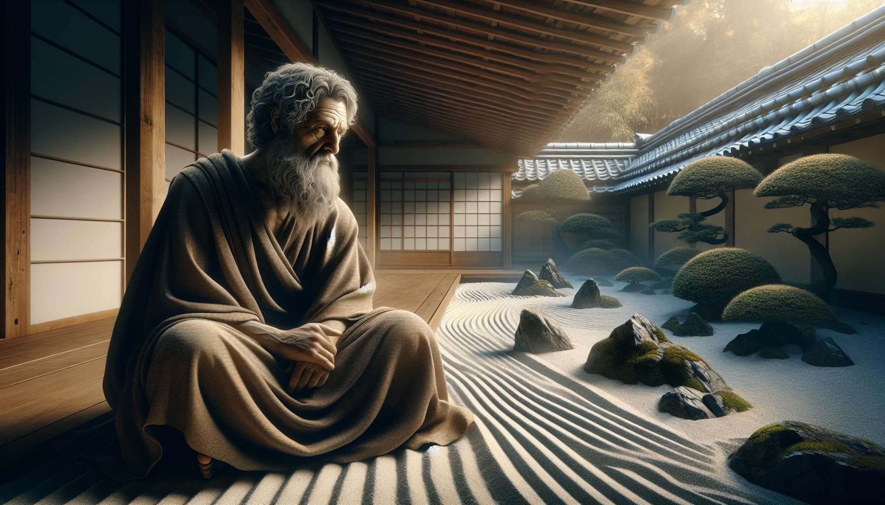

Ikigai and Stoic philosophy share deep affinities in their quest for meaning, resilience, and wisdom. Stoicism, a philosophical current founded by Zeno of Citium in the fourth century B.C., emphasizes self-mastery, acceptance of fate, and the pursuit of virtue. These principles find a powerful echo in the concept of Ikigai, which invites the discovery and pursuit of one's reason for being, cultivating alignment between one's values, talents, and the needs of the world.  
  
One of the pillars of Stoicism is the distinction between what depends on us and what does not. The stoics teach to focus on what we can master, such as our judgments, our actions, and our attitude towards events, rather than being disturbed by external circumstances that we cannot control. This idea resonates with the philosophy of Ikigai, which encourages focusing on what is truly important to us, acting in accordance with our deep values, and finding meaning in activities that fully engage us.  
  
Epictetus, one of the greatest Stoic philosophers, stated, "It is not the things themselves that trouble us, but the opinions we have of them." This maxim underlines the importance of cultivating a resilient and adaptable mind, capable of facing life's challenges with serenity and wisdom. Ikigai, in inviting us to discover and pursue our reason for being, helps us develop this inner resilience. When we are engaged in activities that mean something to us, we are better able to overcome obstacles and find a balance in the face of life's ups and downs.  
  
Stoicism and Ikigai also share a view of life as a process of continued learning and growth. The Stoics believed that true wisdom does not lie in the accumulation of theoretical knowledge, but in the daily practice of ethical principles. Similarly, Ikigai is not limited to a simple intellectual quest, but is realized in action and commitment. It is by cultivating our passions, developing our skills, and contributing to the well-being of others that we give life to our Ikigai and find a deep sense of meaning in our existence.  
  
Marcus Aurelius, Roman emperor and Stoic philosopher, encourages us to embrace the present moment and make every instant an opportunity to live in accordance with our values. In his "Meditations", he writes: "Set aside the future therefore: you have no control over it. Lie on the present, where you have a say." This injunction to focus on the here and now, to act with integrity, and to find meaning in daily tasks, echoes the philosophy of Ikigai. By grounding ourselves in the present and fully engaging in what we are doing, we create the conditions conducive to the emergence of our Ikigai.  
  
A striking example of the convergence between Stoicism and Ikigai is that of Nelson Mandela, South African political leader and humanist. During his 27 years of imprisonment, Mandela drew on Stoic teachings to cultivate resilience, self-control, and clarity of mind. He turned his ordeal into an opportunity for inner growth and service to others. In pursuing his Ikigai, his deep reason for being - the struggle for the freedom and dignity of his people - Mandela found the strength to persevere and transform his fate into a powerful message of hope and reconciliation.  
  
Stoicism and Ikigai invite us to cultivate a virtuous life, aligned with our deepest values and oriented towards serving others. They encourage us to develop our resilience in the face of life's challenges, to find meaning in daily activities, and to pursue our reason for being with determination and wisdom. By integrating Stoic principles into our Ikigai quest, we can develop an inner compass that guides us towards a life fully lived, rich in meaning and contributing to the common good.  
  
In this way, Stoic philosophy provides fertile ground to nurture and deepen our reflection on Ikigai. It invites us to cultivate self-mastery, serene acceptance of fate, and engagement in virtuous actions. By integrating these principles into our quest for meaning and fulfillment, we can develop inner resilience and mental clarity that allow us to navigate wisely through the twists and turns of existence. Ikigai, enriched by Stoic wisdom, then becomes a way of life, a compass that guides us towards an authentic, fulfilling, and meaningful life.  
  
Key takeaways:  
  
1. Ikigai and Stoicism share deep affinities in their quest for meaning, resilience, and wisdom.  
  
2. Stoicism teaches to focus on what we can control, such as our judgments, actions, and attitude towards events, an idea that resonates with the philosophy of Ikigai.  
  
3. Ikigai and Stoicism emphasize the importance of cultivating a resilient and adaptable mind, capable of facing life's challenges with serenity and wisdom.  
  
4. Both philosophies share a vision of life as a process of continued learning and growth, where wisdom is realized in action and commitment.  
  
5. Stoicism and Ikigai encourage us to embrace the present moment and to make each instant an opportunity to live in accordance with our values.  
  
6. The example of Nelson Mandela illustrates the convergence between Stoicism and Ikigai, showing how resilience and the pursuit of a deep purpose can transform trials into opportunities for growth and service to others.  
  
7. By integrating Stoic principles into our Ikigai quest, we can develop an inner compass that guides us towards a life fully lived, rich in meaning, and contributing to the common good.