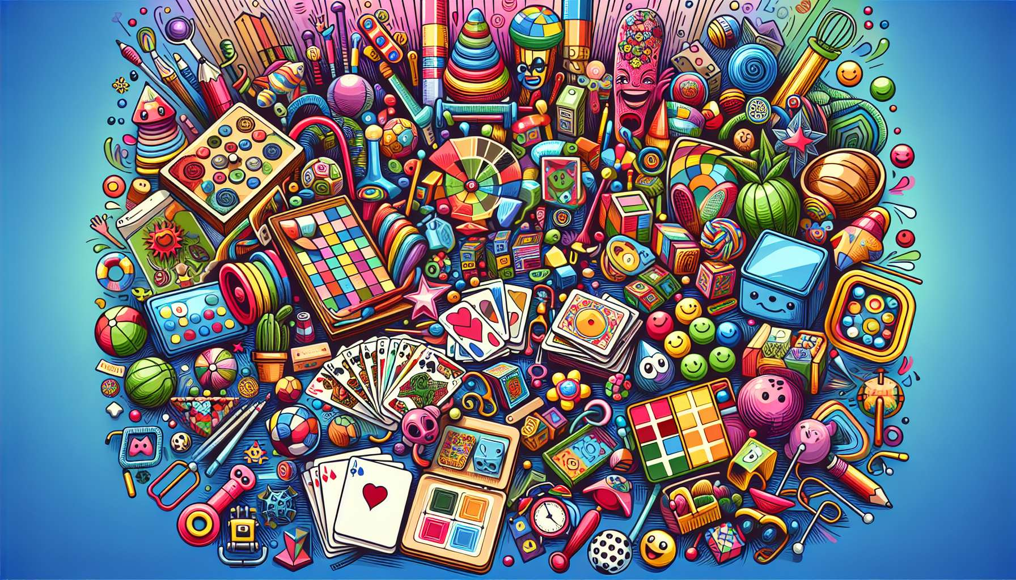

Games and toys are essential tools in laughter therapy. They create a playful atmosphere, encourage interaction between participants, and stimulate creativity and spontaneity, which are key elements for eliciting laughter and good humor.  
  
Laughter-oriented board games, like card games or humorous board games, provide a structured environment for amusing exchanges. They promote conviviality, complicity, and team spirit. For example, a card game where participants have to invent jokes or funny stories from the drawn cards can quickly trigger contagious laughter. Games of mime or charades are also highly appreciated for their theatrical and interactive aspect. They allow participants to express themselves with their bodies, let go, and laugh together at the comical situations that arise.  
  
Toys and fun gadgets are other valuable tools to promote laughter. Unusual objects, funny stuffed animals, toys that make amusing noises, or surprising gadgets can be used to 'break the ice' and create shared laughter moments. For example, circulating a toy that makes a fart sound can quickly relax the atmosphere and generate collective hilarity. Toys and gadgets provide a tactile and sensory dimension that promotes engagement and participation.  
  
Role-playing games and humoristic improvisations are also very effective in stimulating interaction and laughter. By adopting quirky characters or improvising funny skits, participants are encouraged to 'step out of their comfort zone', explore different facets of themselves, and co-create situations conducive to laughter. Role-playing games help trivialize stressful or embarrassing situations by addressing them with humor and lightness. They also promote empathy and mutual understanding by allowing participants to put themselves in someone else's shoes.  
  
It is important to choose games and toys that suit the participants' profiles and needs. For children, simple, colorful, and safe games that appeal to their imagination and spontaneity should be prioritized. For adults, more sophisticated or offbeat games that tap into their irony and sense of humor can be proposed. The goal is to find tools that generate interest, curiosity, and a desire to play.  
  
The laughter therapist needs to be creative and flexible in using games and toys. They can divert the rules, invent variations or fun challenges to renew interest and surprise participants. They also need to be attentive to group dynamics and ensure that everyone finds their place and enjoys the proposed activities. The goal is to create an atmosphere of trust and benevolence where laughter and good humor can freely express themselves.  
  
Finally, games and toys can be used as supports for visualization or laughter meditation exercises. For example, participants could be asked to imagine themselves playing their favorite game and to feel the associated positive emotions, or to visualize a toy that symbolizes their inner joy. These exercises help reinforce the benefits of laughter by anchoring positive sensations and images in the participants' minds.  
  
In conclusion, games and toys are valuable allies for the laughter therapist. They offer an infinite playground to stimulate interactions, creativity, and laughter. Well-chosen and used appropriately, they strengthen group cohesion, promote letting go and contribute to creating a joyful and benevolent atmosphere conducive to the well-being and fulfillment of everyone. Combined with other tools of laughter therapy, such as props (module 8.1) or audio-visual supports (module 8.2), they help create rich, varied and memorable sessions that bring real added value to the participants.  
  
Key points:  
  
- Games and toys are essential tools in laughter therapy for creating a playful atmosphere, encouraging interactions and stimulating creativity and spontaneity.  
   
- Laughter-oriented board games, such as card games or humorous board games, encourage conviviality, complicity, and team spirit.  
  
- Amusing toys and gadgets provide a tactile and sensory dimension that promotes engagement and participation.  
   
- Role-playing games and humoristic improvisations help trivialize stressful situations, promote empathy, and mutual understanding.  
   
- It is important to choose games and toys that suit the participants' profiles and needs to arouse their interest and the desire to play.  
  
- The laughter therapist needs to be creative and flexible in using games and toys, while being attentive to group dynamics.  
   
- Games and toys can be used as supports for visualization or laughter meditation exercises, further enhancing the therapy's benefits.  
   
- Combined with other tools, games and toys help create rich, varied, and memorable sessions that contribute to the well-being and fulfillment of the participants.