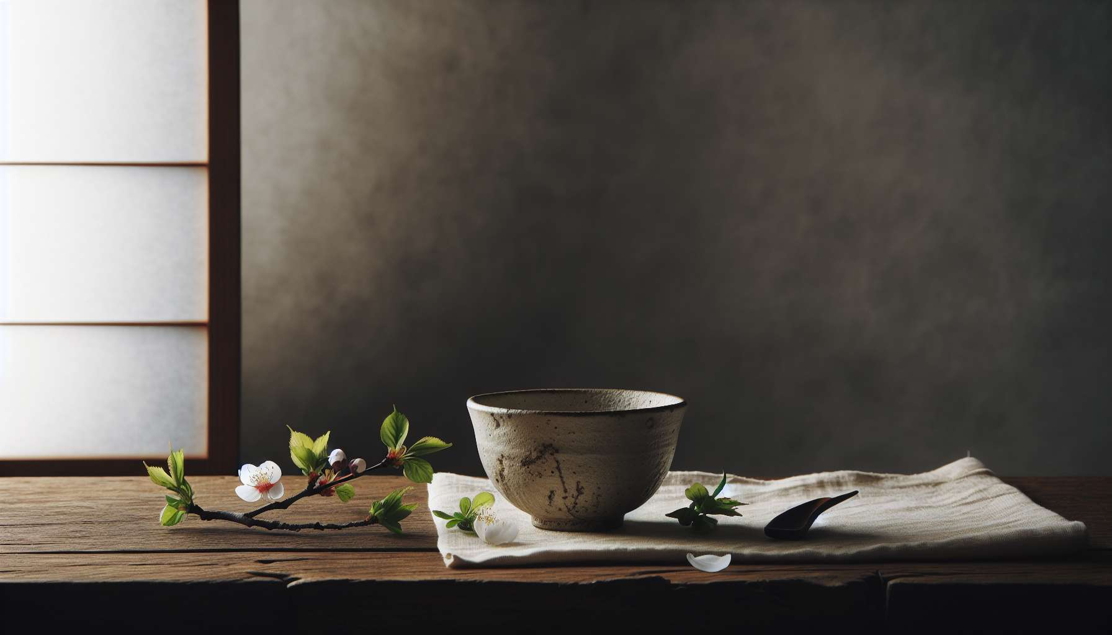

Ikigai and the philosophy of Wabi-Sabi share a deep affinity in their quest for meaning, simplicity, and authenticity. Wabi-Sabi, a Japanese aesthetic and spiritual concept, invites us to find beauty in imperfection, impermanence, and incompleteness. This world view, imbued with wisdom and serenity, offers valuable insights into the concept of Ikigai and how to cultivate a meaningful existence.  
  
At the heart of Wabi-Sabi is the idea that nothing is perfect, permanent, or finished. Each being, each object, each situation carries within it the traces of time passing, the trials endured, and imperfections that make it unique. Rather than wanting to erase these rough spots, Wabi-Sabi invites us to embrace them with kindness, to see them as a source of beauty and depth. This serene acceptance of imperfection resonates with the quest for Ikigai, which encourages us to embrace our inner nature, with its strengths and weaknesses, to find our unique place in the world.  
  
Wabi-Sabi celebrates simplicity, sobriety, and the essence of things. In a world often marked by overconsumption and superficiality, this philosophy reminds us of the value of the essential, of what lasts, and nourishes the soul. It invites us to shed the superfluous to focus on what really matters, on the activities and relationships that bring deep meaning to our existence. This pursuit of the essential echoes the concept of Ikigai, encouraging us to identify and cultivate the passions and talents that make our being vibrate, rather than dispersing ourselves in vain and ephemeral pursuits.  
  
A striking example of the convergence between Wabi-Sabi and Ikigai is the Japanese tea ceremony, or "chadō". This ancient art of preparing and serving matcha tea according to a codified ritual embodies the principles of Wabi-Sabi in every gesture and object. The tea bowls, often asymmetrical and scattered with imperfections, celebrate the beauty of the unique and ephemeral. The slow, meditative rhythm of the ceremony invites us to connect with the present moment, to appreciate the simplicity of a shared moment. For the tea masters, this art is more than a mere hobby: it is an Ikigai, a path of self-realization and connection with others and the world.  
  
Wabi-Sabi also teaches us the art of impermanence, the ability to appreciate the fleeting beauty of every moment. In a ever-changing world, where nothing lasts forever, this philosophy invites us to cultivate a form of serene detachment, to welcome transitions and endings with grace and gratitude. This wisdom of impermanence can nourish our quest for Ikigai, reminding us of the importance of fully committing to the present, of savoring each step of the journey rather than focusing on the destination. It encourages us to embrace the seasons of our lives, to find meaning and beauty in every phase of our existence.  
  
The philosophy of Wabi-Sabi also invites us to cultivate a perspective filled with curiosity and wonder about the world around us. It teaches us to find poetry in the details of everyday life, to appreciate the patina of time on objects and beings. This attention to the small things, this ability to marvel at life in all its diversity, is a valuable quality to nourish our Ikigai. By cultivating an attitude of curiosity and gratitude, we open our minds and hearts to new sources of inspiration and meaning. We learn to find our reason for being in simple gestures and daily encounters, rather than seeking it in grandiose and distant pursuits.  
  
Wabi-Sabi and Ikigai thus invite us on a quest for meaning grounded in the acceptance of our imperfect and changing nature. They encourage us to find our unique path by cultivating simplicity, authenticity, and presence in the moment. By embracing the beauty of impermanence and nourishing our ability to marvel, we create the conditions conducive to the emergence and flourishing of our Ikigai. This timeless wisdom, drawn from Japanese aesthetics, provides a valuable guide to navigate the meanderings of existence and forge our own path towards a life rich in meaning and poetry.  
  
The meeting between Wabi-Sabi and Ikigai thus opens a space for reflection and contemplation on the art of living and the quest for meaning. It invites us to embrace our humanity in all its complexity and fragility, to find our unique place in the grand ballet of existence. By cultivating a gaze imbued with kindness, curiosity, and gratitude towards ourselves and the world around us, we create the conditions conducive to the emergence of our Ikigai. This aesthetic and spiritual approach offers us a path of wisdom and self-realization, inviting us to live fully and authentically, in harmony with our deep nature and the rhythms of the universe.  
  
Key points to remember:  
  
1. Wabi-Sabi and Ikigai both pursue meaning, simplicity, and authenticity.  
  
2. Wabi-Sabi invites us to find beauty in imperfection, impermanence, and incompleteness by accepting our inner nature with its strengths and weaknesses.  
  
3. This philosophy celebrates the simplicity and essence of things by encouraging us to focus on what really matters and cultivate our passions and talents.  
  
4. The Japanese tea ceremony embodies the principles of Wabi-Sabi and Ikigai by celebrating the beauty of the unique and ephemeral and inviting us to connect to the present moment.  
  
5. Wabi-Sabi teaches the art of impermanence, reminding us of the importance of engaging fully in the present and savoring each step of the journey.  
  
6. This philosophy invites us to cultivate a perspective filled with curiosity and wonder on the world around us, finding poetry in everyday details.  
  
7. Wabi-Sabi and Ikigai encourage us to embrace our humanity in all its complexity and fragility by cultivating a kind, curious, and grateful viewpoint towards ourselves and the world.  
  
8. This aesthetic and spiritual approach offers a path of wisdom and self-realization, inviting us to live fully and authentically in harmony with our deep nature and the rhythms of the universe.