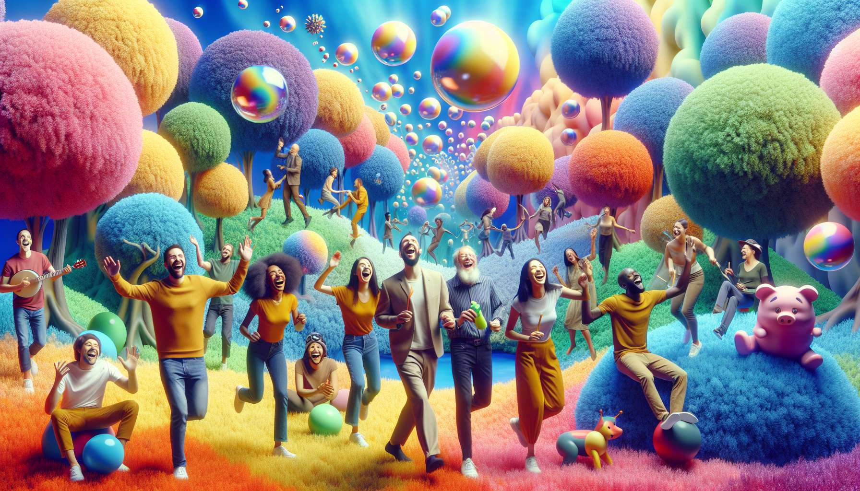

Visualization and positive mental imagery techniques are powerful tools for laughter therapy. They consist of utilizing the power of imagination to create pleasant, amusing, and stimulating mental images, conducive to fostering a positive and laughter-friendly state of mind. By focusing on joyful and light inner representations, it can positively influence one's emotions, sensations and even physiology.  
  
One of the key principles of these techniques is that the brain does not always distinguish between a real and imagined experience. Thus, by visualizing a funny and enjoyable scene, it can trigger physical and emotional responses similar to those one would have while actually experiencing the situation. For example, imagining being tickled by giant feathers can create sensations of tickling and genuine laughter!  
  
Humorous visualization exercises can take many forms. A classic is the "imaginary journey in a wacky world", where participants are invited to close their eyes and visualize themselves in a whimsical and entertaining universe, guided by the instructor's voice. This can be a world where animals talk and dance the salsa, where houses are made of chocolate and cars of marshmallow, where people walk on their hands and sneeze glitter. The aim is to let your fantasy run wild and have fun with the unusual images that emerge, without censoring yourself.  
  
Another effective technique is the "humorous transformation of stressful situations". This involves imagining a scene that worries or stresses us, then gradually modifying it by incorporating comical and absurd elements, until it becomes completely ludicrous and harmless. For example, if one dreads an exam, one can visualize the examiners wearing clown costumes and asking questions like "How many bubbles are there in a bar of chocolate?" or "What is the cry of the wild carrot?". By playfully belittling our fears, we deactivate them and strengthen our self-confidence.  
  
Mental imagery can also be used to project oneself positively and amusingly into future situations. Before a job interview, for example, one can imagine making a triumphal entrance into the recruiter's office, dressed as a superhero, cape fluttering and epic music in the background. Or envision the recruiter awed by our 3D pop-up CV and our answers so brilliant that they literally blind him. These offbeat representations allow us to approach the event with more lightness and confidence, while connecting with our inner resources.  
  
A striking example of the effectiveness of these techniques is that of Jean, a fifty-something with depression and anxiety disorders. During a laughter therapy session, he was invited to visualize his depression as a grumpy and grumbling cartoon character, preventing him from enjoying life. By mentally dialoguing with this character and gradually making fun of it, Jean succeeded in distancing himself from his dark thoughts. He, notably, imagined the face this "Mr. Gloom" would make if he suddenly started dancing the Macarena in a hot pink tutu! This ludicrous representation induced a liberating bout of laughter in Jean and a realization of his ability to no longer be controlled by his negative thoughts.  
  
Beyond their immediate effects, humorous visualization techniques also have long-term benefits. They help to develop creativity, mental flexibility and the ability to adapt to situations with flexibility and optimism. By regularly practicing altering one's inner representations positively and amusingly, it fosters a form of self-deprecating humor and resilience towards life's uncertainties.  
  
During a laughter therapy workshop in a retirement home, an octogenarian named Simone testified about the benefits she gained from these exercises. Faced with chronic pain and a loss of independence, she tended to mope and focus on her limitations. By learning to visualize her pains as small mischievous and clumsy imps, jumping on her body like a trampoline, she managed to humorously and tenderly tame them. She took inward amusement in imagining these imps tripping over her joints and apologizing for their clumsiness with comical bows. This offbeat representation helped her to dramatize her condition and focus on the positive aspects of her life, like the joy of sharing laughter-filled moments with her friends.  
  
It's important to note that to make the most of these techniques, it is essential to let your mind play freely, without judging or censoring yourself. The facilitator must create a climate of trust and kindness, where everyone feels allowed to let the most whimsical and personal images emerge. They can suggest visualization cues, but also encourage participants to create their own humorous scenarios, based on their experiences and sensibilities.  
  
In summary, visualization and positive mental imagery techniques are remarkable allies for cultivating inner laughter and the lightness of being. By playing with mental representations and tinting them with humor, one develops greater inner freedom and resilience to life's challenges. We learn not to be trapped by fears, doubts, or limitations, but to transform them into opportunities for laughter and growth. Most importantly, we reconnect with that childlike part of ourselves, the ability to marvel, imagine and believe in the magic of laughter.  
  
Key Points:  
  
- Visualization and positive mental imagery techniques are powerful tools for laughter therapy. They involve using the power of imagination to create pleasant, amusing, and stimulating mental images.  
  
- The brain doesn't always differentiate between a real and an imagined experience. Therefore, by visualizing a funny scene, it can trigger physical and emotional responses similar to those experienced in a real situation.  
  
- Humorous visualization exercises can take many forms, such as the "imaginary journey in a wacky world" or the "humorous transformation of stressful situations".  
  
- Mental imagery can also be used to project oneself into future situations in a positive and amusing way, making the event more approachable with lightness and confidence.  
  
- Beyond their immediate effects, humorous visualization techniques also have long-term benefits. They help to develop creativity, mental flexibility, and the ability to adapt to situations with optimism.  
  
- Maximized use of these techniques requires free-play of the mind, without judgement or self-censorship. The facilitator must create a climate of trust and kindness.  
  
- By playing with mental representations and coloring them with humor, greater inner freedom and resilience to life's challenges is developed. It reconnects one to the ability to marvel, imagine and believe in the magic of laughter.