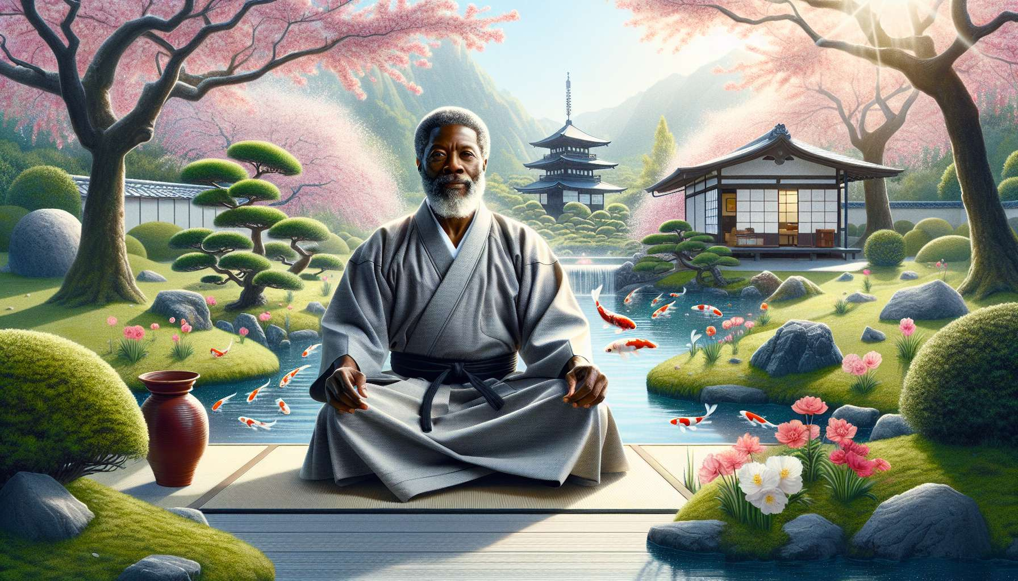

Developing one's own practice of Ikigai is an essential aspect of the journey of an Ikigai Coach. Beyond being a simple concept to teach, Ikigai is a philosophy of life to embody on a daily basis. By cultivating a deep and authentic relationship with their own Ikigai, the coach inspires and guides their clients in a consistent and coherent manner.  
  
Clarifying and affirming one's personal Ikigai is the starting point of this approach. The Ikigai Coach embarks on honest introspection to identify what brings meaning and flavor to their life. They explore their passions, talents, values, and their contribution to the world. This process requires courage, humility, and patience. It is by facing their own doubts, fears, and resistances that the coach develops a compassion and clarity valuable for accompanying their clients.  
  
For example, an Ikigai Coach might realize that their Ikigai is "awakening others' potential through a kind and creative presence". This clarity serves as a compass to guide their professional and personal choices.  
  
Aligning their lifestyle with their Ikigai is the next step. The Ikigai Coach strives to live in coherence with what is essential for them. They arrange their schedule, activities, and relationships to honor their Ikigai. This can involve courageous choices, such as leaving a job which is no longer nourishing, or investing in a meaningful project even if it is not lucrative initially. The coach learns to listen and follow their intuition, daring to step out of their comfort zone to remain true to their Ikigai.  
  
Concretely, a coach whose Ikigai is to "promote kind and fulfilling education" might decide to reduce their corporate interventions to develop Ikigai workshops in schools.  
  
Deepening their practice of Ikigai over time is an ongoing commitment. The Ikigai Coach cultivates a beginner's attitude, open and curious. They experiment with new approaches, refine their tools, seek to excel themselves. They nurture their Ikigai through reading, training, exchanges with inspiring peers. They are also aware of signs of stagnation or loss of meaning, which could indicate a need for renewal. As Ikigai is a permanent learning journey, the coach embraces turns and challenges as opportunities for growth.  
  
For example, a coach whose Ikigai is "to bring joy and lightness to learning" may train in theatrical improvisation and clowning to enrich their intervention palette.  
  
Sharing one's experience of Ikigai with authenticity is a powerful way to inspire and encourage clients. The Ikigai Coach does not position themselves as an infallible expert, but as a humble and sincere companion. They testify to their own challenges, doubts, and learnings in the quest for Ikigai. They invite the client to explore their unique path, without trying to impose their truth. This vulnerability and authenticity create an atmosphere of trust and reciprocity conducive to transformation.  
  
Concretely, a coach can share with a client their own journey towards greater alignment, by mentioning, for example, a difficult but liberating decision they made in listening to their Ikigai.  
  
Monitoring their personal and relational ecology is a crucial aspect of the practice of Ikigai. The coach is mindful of maintaining a healthy balance between taking care of themselves and taking care of others. They respect their own energetic and emotional boundaries. They allow themselves times for renewal and joy, in coherence with their Ikigai. They cultivate nourishing and inspiring relationships, both personally and professionally. This global ecology allows them to radiate their own vitality and infuse it into their guidance.  
  
For example, a coach whose Ikigai is "to create beauty and harmony" will make sure to surround themselves with an aesthetic living environment, to practice a regular artistic activity, and to collaborate with professionals who share this value.  
  
By developing their own practice of Ikigai, the coach embodies a path of fulfillment and contribution which they invite their clients to explore in their unique ways. They become an inspiring model of alignment and authenticity, while remaining deeply human and accessible. This exemplarity by being rather than doing is at the heart of the posture of the Ikigai Coach.  
  
Key takeaways:  
  
- The Ikigai Coach must develop their own practice of Ikigai to embody this life philosophy in an authentic and inspiring way for their clients.  
  
- Clarifying and affirming one's personal Ikigai is the starting point. This demands honest and courageous introspection to identify what brings purpose and zest to one's life.  
  
- Aligning one's lifestyle with their Ikigai is vital. The coach arranges their daily activities and makes decisions in tune with what truly matters to them.  
  
- Deepening their Ikigai practice is an ongoing journey. The coach cultivates a beginner's attitude, seeks to enhance their skills, and embraces challenges as learning opportunities.  
  
- Sharing one's Ikigai experience with authenticity helps inspire clients. By sharing their own challenges and learnings, the coach creates an atmosphere of trust and reciprocity.  
  
- Monitoring one's personal and relational ecology is crucial. The coach is mindful of respecting their own limits, replenishing themselves, and surrounding themselves with nourishing relationships, in tune with their Ikigai.