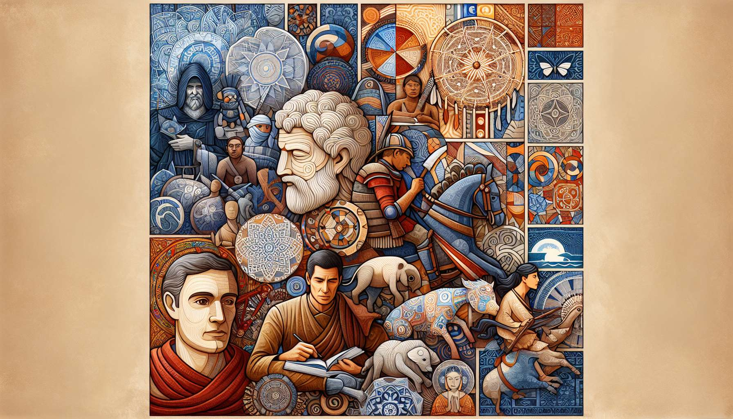

The concept of Ikigai, although originating from Japan, finds echoes in many cultures around the world and at different times. This universality testifies to the fundamental quest of the human being to give meaning to their existence and find their place in the world. By exploring Ikigai through ages and cultures, we can discover ancient wisdom and new perspectives to enrich our own journey.  
  
In ancient Greece, the notion of eudaimonia is similar to Ikigai. This term, often translated as "happiness" or "fulfillment", actually refers to a state of fullness and realization of one's potential. For Greek philosophers like Aristotle, eudaimonia is achieved by cultivating excellence (arété ) in all areas of life, developing one's virtues, and contributing to the common good. This holistic vision of fulfillment, combining personal development and commitment in the world, resonates with the quest for Ikigai.  
  
In Buddhist tradition, which has deeply influenced Japanese culture, parallels with Ikigai can also be found. Buddha's teachings invite us to find the middle way, a balance between extremes, to achieve liberation from suffering. This path involves self-knowledge, the practice of meditation and the development of qualities such as compassion, wisdom and equanimity. By cultivating an ethical life and by serving others, the Buddhist practitioner gives deep meaning to their existence, reminiscent of the quest for Ikigai.  
  
In Africa, the philosophy of Ubuntu embodies a worldview focused on interdependence and connection between all beings. The proverb "I am because we are" conveys the idea that individual identity and fulfillment are inseparable from the community and collective well-being. This African wisdom invites us to find our purpose in our contribution to social harmony and solidarity. Like Ikigai, Ubuntu reminds us that our personal achievement comes through our commitment to others and the world around us.  
  
In Native American traditions, the vision quest is a rite of passage that allows each individual to find their place and mission in the community. By withdrawing into nature, fasting, and meditating, the young adult seeks to connect with their inner guide and to receive a vision that will guide their life. This practice illustrates the importance given to introspection, listening to one's inner voice, and alignment with the forces of nature to find one's Ikigai. It invites us to reconnect with the essentials and to draw from our deep wisdom to give meaning to our existence.  
  
In the Middle Ages in Europe, the quest for the Grail embodies the search for a spiritual ideal and personal accomplishment. The knights of the Round Table, embarking on the search for this sacred chalice, symbolize the initiatory quest of the human being to find their true nature and realize their potential. This legend teaches us that the real treasure is not in an external object, but in inner transformation and the awakening of consciousness. Like Ikigai, the quest for the Grail invites us to engage in personal journey, to confront our shadows and discover our inner light.  
  
Through the ages and cultures, we thus find echoes of Ikigai in various spiritual, philosophical and initiatory traditions. These universal wisdoms remind us that the search for meaning and fulfillment is inherent to the human condition, beyond times and borders. By exploring these different perspectives, we can broaden our understanding of Ikigai and enrich our own existential journey.  
  
It's important to note that Ikigai is not a fixed or dogmatic concept, but an invitation to find our own path to fulfillment in line with our culture, values and individuality. Each person, each community, each era can appropriate the essence of Ikigai and give it a unique color. The challenge isn't to reproduce identically an ancient formula, but to draw inspiration from these wisdoms to create our own art of living, anchored in our reality and our deep aspiration.  
  
By exploring Ikigai through ages and cultures, we can thus draw inspirations and valuable teachings for our own quest for meaning. These universal wisdoms invite us to cultivate self-knowledge, harmony with the world and commitment to others to realize our potential and contribute to the common good. They remind us that our Ikigai is a personal and evolving journey, which is nourished by our cultural heritage while adapting to our time and individuality. By opening ourselves to these different perspectives, we can enrich our understanding of Ikigai and trace our own path to fulfillment, resonating with our deep being and in harmony with the world around us.  
  
Takeaways :  
  
1. Ikigai, a Japanese concept of purpose, finds echoes in many cultures and traditions around the world and through the ages, testifying to the universality of the quest for meaning and fulfillment.  
  
2. In ancient Greece, the concept of eudaimonia is close to Ikigai, inviting us to cultivate excellence and contribute to the common good to achieve fulfillment.  
  
3. The Buddhist tradition, which has influenced Japanese culture, teaches the middle way and the liberation from suffering through self-knowledge, meditation and service to others.  
  
4. African philosophy of Ubuntu emphasizes the interdependence between the individual and the community, reminding us that personal achievement goes through commitment to others and the world.  
  
5. Indigenous traditions, through the vision quest, stress the importance of introspection, listening to one's inner voice, and alignment with nature to find one's place and mission.  
  
6. The quest for the Grail in the Middle Ages symbolizes the search for a spiritual ideal and the inner transformation necessary to realize one's potential.  
  
7. Ikigai is not a fixed concept, but an invitation to find one's own path to fulfillment by drawing inspiration from universal wisdoms while adapting them to one's culture, values and individuality.  
  
8. Exploring Ikigai through ages and cultures helps enrich one's own quest for meaning by cultivating self-knowledge, harmony with the world and commitment to others.