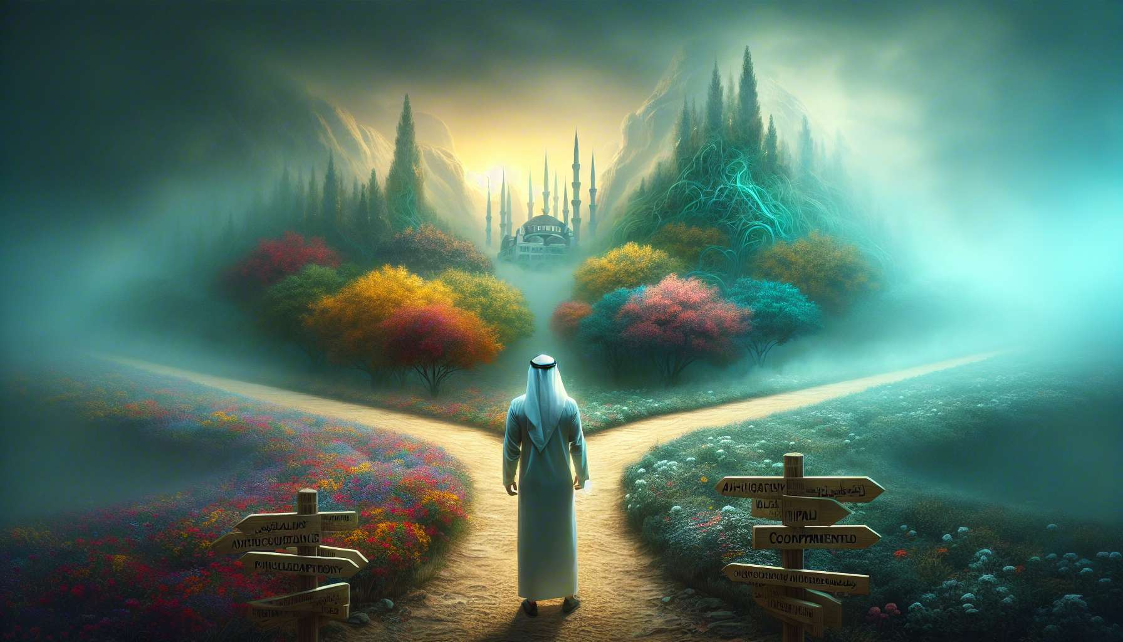

Ikigai and existentialism share a common quest for meaning and authenticity in a world often perceived as absurd and devoid of inherent significance. Existentialism, a philosophical movement that emerged in the twentieth century, emphasises individual freedom and responsibility in creating the meaning of one's own life. This vision deeply resonates with the concept of Ikigai, which invites each individual to discover and pursue their unique purpose in life, drawing on their passions, talents, and contributions to the world.  
  
Jean-Paul Sartre, an emblematic figure of existentialism, affirmed that "existence precedes essence". In other words, human beings do not have a predefined nature, but are condemned to be free and to define the meaning of their existence through their choices and actions. This idea finds a powerful echo in the philosophy of Ikigai, which encourages each individual to take charge of their destiny and shape a life that reflects their deep aspirations. Ikigai is not something given, but a personal quest that is built over time through experiences and commitments.  
  
Existentialism also underscores the importance of authenticity, that is, being true to oneself and one's values, even in the face of social pressure and external expectations. This notion of authenticity is at the heart of Ikigai, which encourages alignment of actions with one's true nature and pursuit of what deeply inspires us, rather than conforming to imposed roles. By cultivating self-awareness and acting in accordance with our aspirations, we bring our Ikigai to life and assert our unique and irreplaceable existence.  
  
Another point of convergence between existentialism and Ikigai is the recognition of the finite nature of existence and the need to use it consciously and responsibly. Existentialists, like Martin Heidegger, highlighted the temporal and mortal character of the human condition, inviting full engagement in the present and finding meaning in existence, rather than being lost in inauthenticity and evasion. Similarly, Ikigai encourages awareness of life's brevity and making choices that reflect our deepest priorities and values. By pursuing our purpose, we give direction and intensity to our existence while serenely accepting its ephemeral character.  
  
Existentialism and Ikigai also invite us to embrace the tragic dimension of existence, marked by joys and sufferings, successes and failures. Rather than denying life's difficulties and absurdities, they encourage confronting them with courage and clarity, finding opportunities for growth and self-transcendence. Ikigai, by anchoring us in a meaningful project, gives us the strength to persevere in the face of obstacles and turns challenges into opportunities for learning and resilience.  
  
A striking example of the convergence between existentialism and Ikigai is Viktor Frankl, a psychiatrist and survivor of the Nazi concentration camps. In his book "Man's Search for Meaning", Frankl demonstrates the critical importance of finding meaning in his existence, even in the most extreme conditions. He describes how, by clinging to a meaningful project - writing a book about his camp experiences - he found the strength to survive and maintain hope. This quest for meaning, at the heart of Frankl's logotherapy, echoes the concept of Ikigai, which invites us to discover and pursue what gives direction and value to our lives.  
  
Existentialism and Ikigai remind us that the meaning of life is not something given, but a personal creation that is shaped through our choices, commitments and way of living in the world. They encourage us to take charge of our destiny, to cultivate authenticity, and to pursue what resonates deeply within us. By embracing life's tragic dimension and committing to meaningful projects, we add direction and intensity to our lives while serenely accepting finitude.  
  
Simone de Beauvoir, existentialist philosopher, asserted: "There is no a priori justification for life: it is up to each person to give it meaning, and value is nothing other than this chosen meaning." This quote powerfully summarises the convergence between existentialism and Ikigai: the meaning of our lives is a unique and personal creation, built through our commitments and our way of living in the world. In pursuing our Ikigai, we affirm our freedom and responsibility in shaping an authentic and meaningful existence.  
  
Thus, existentialism provides powerful insights into the quest for Ikigai, highlighting the importance of freedom, authenticity and commitment in creating the meaning of one's life. It invites us to embrace the human condition in all its complexity, facing absurdity and finitude with courage and lucidity. By integrating these existential principles into our pursuit of Ikigai, we can develop a life fully owned, rooted in projects reflecting our uniqueness and contribution to the world. Ikigai, nurtured by existentialist wisdom, becomes a conscious and engaged art of living, an affirmation of our freedom and responsibility in shaping an authentic and meaningful existence.  
  
Key takeaways :  
  
1. Ikigai and existentialism share a common quest for meaning and authenticity in a world often perceived as absurd and devoid of inherent meaning.  
  
2. Existentialism emphasises individual freedom and responsibility in creating the meaning of one's life, a vision that resonates with the concept of Ikigai.  
  
3. Authenticity, that is being true to oneself and one's values, is at the heart of both Ikigai and existentialism.  
  
4. Ikigai and existentialism recognise the finite nature of existence and the necessity of using it consciously and responsibly.  
  
5. They invite embracing life's tragic dimension, finding growth and self-transcendence opportunities in difficulties.  
  
6. Viktor Frankl, psychiatrist and survivor of Nazi concentration camps, illustrates the convergence between existentialism and Ikigai by emphasising the importance of finding meaning in one's existence, even in the most extreme conditions.  
  
7. Existentialism and Ikigai remind us that the meaning of life is a personal creation that is shaped through our choices, commitments and way of living in the world.  
  
8. By pursuing our Ikigai, nurtured by existentialist wisdom, we can develop a fully owned life, rooted in projects reflecting our singularity and contribution to the world.