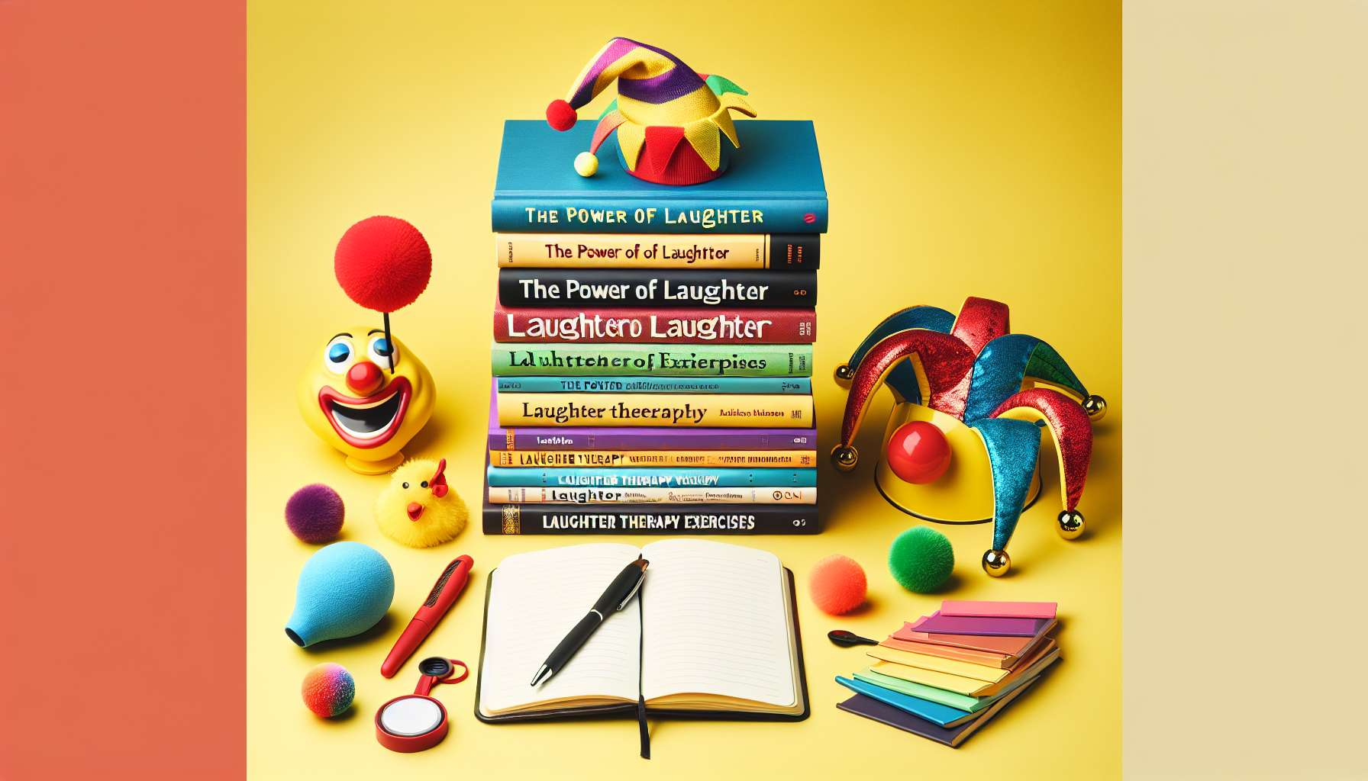

Books and documentary resources on laughter and humor are valuable tools for deepening one's knowledge and enriching one's laughter therapy practice. They provide a solid theoretical foundation, inspirational testimonials, and concrete ideas for developing one's laughter therapist toolbox.  
  
Among the must-have reference works, we can mention "Laughter, a Therapy for All" by Dr. Madan Kataria, the founder of laughter yoga. This book traces the history and principles of this approach, as well as numerous exercises and testimonials. It is an excellent starting point for understanding the foundations and benefits of laughter therapy. In a more scientific register, "Laughter, a Medicine for Body and Mind" by Dr. Lee Berk presents the latest research on the physiological and psychological effects of laughter, demonstrating its therapeutic virtues.  
  
To delve deeper into understanding the mechanisms of humor, "Laughter: An Essay on the Meaning of the Comic" by Henri Bergson offers a philosophical and aesthetic analysis of laughter, exploring its psychological and social springs. "Humor" by Sigmund Freud, on the other hand, approaches laughter from a psychoanalytical angle, as a defense and sublimation mechanism. These works help to better understand the mental and emotional processes at work in laughter and humor.  
  
Beyond theoretical essays, practical books are filled with concrete tools for conducting laughter therapy sessions. "The Big Book of Laughter Games" by Corinne Cosseron offers a multitude of exercises and collective games to stimulate laughter and group cohesion. "Laughter without Reason" by Madan Kataria, on the other hand, offers a complete methodology for creating and running laughter clubs. These books are true mines of ideas and inspiration for designing varied sessions adapted to different audiences.  
  
Personal development books can also be valuable resources for the laughter therapist. "The Power of Laughter" by Franck Lopvet explains how to cultivate positive humor on a daily basis to improve one's well-being and relationships. "Laughter that Heals" by Annette Goodheart testifies to the author's journey, who overcame cancer thanks to laughter and positive thinking. These embodied accounts show the transformative power of laughter and provide keys to integrating it into one's life.  
  
Comics, novels, and humorous collections are other interesting materials to exploit in laughter therapy. They allow building a repertoire of funny stories, funny situations, and zany characters from which to draw to conduct sessions. They are also good tools for working on humor and creativity with the participants, for example by inviting them to invent the continuation of a gag or to get inspired by a funny character.  
  
Finally, there are numerous online resources on laughter and humor: websites, blogs, forums, videos, podcasts... These free and easily accessible contents allow staying informed about news and trends in the field, discovering new exercises and sharing experiences with other practitioners. They can be used as educational tools during sessions, for example by watching an inspiring conference or listening to a humorous podcast. They also offer opportunities for continuous training and monitoring for the laughter therapist.  
  
Building a library of resources on laughter and humor is a continuous process that nourishes and renews one's practice. It's important to vary the types of content (theoretical, practical, inspiring...) and the formats (books, comics, videos...) to enrich oneself and adapt to the different needs and preferences of participants. The laughter therapist can invite participants to share their own resources and favorites, thus creating a dynamic of exchange and co-learning around laughter.  
  
In summary, books and documentary resources on laughter and humor are essential allies of the laughter therapist. They provide a knowledge base, practical tools, and sources of inspiration for designing and conducting quality sessions. Along with other supports such as games (module 8.3), accessories (module 8.1), or audiovisual materials (module 8.2), they allow creating a rich and stimulating learning experience that awakens curiosity and the desire to explore further the virtues of laughter.  
  
Key points to remember:  
  
- Books and documentary resources on laughter and humor are valuable tools for deepening one's knowledge and enriching one's laughter therapy practice.   
  
- Among the reference works, there are books tracing the history and principles of laughter yoga, scientific studies on the effects of laughter, philosophical and psychoanalytical analyses of humor, as well as practical guides offering exercises and games.   
  
- Personal development books and inspiring testimonials demonstrate the transformative power of laughter and provide keys for integrating it into one's life.   
  
- Comics, novels, and humorous collections allow building a repertoire of funny stories and tools for working on humor and creativity with participants.   
  
- Online resources (websites, blogs, forums, videos, podcasts) offer free and accessible content for staying informed, discovering new exercises, and sharing with other practitioners.   
  
- Building a diverse library and continuously enriching it nourishes and renews the laughter therapist's practice, adapting to different participant needs and preferences.   
  
- Combined with other supports (games, accessories, audiovisual), books and documentary resources allow creating a rich and stimulating learning experience around the virtues of laughter.