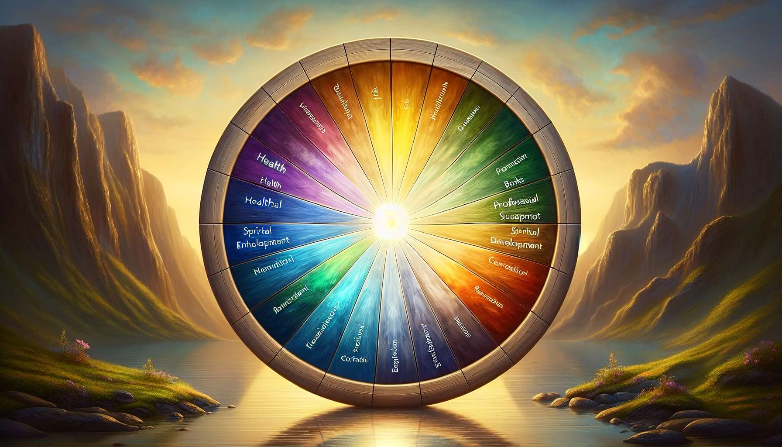

The Wheel of Life is a powerful coaching tool that allows for the assessment of balance and satisfaction in various areas of existence. Within the context of Ikigai coaching, it provides a holistic view of the client's situation and highlights areas of their life that require particular attention in order to achieve optimal alignment with their deepest aspiration.  
  
The coach invites the client to represent their life in the form of a wheel divided into several sectors, each corresponding to a key area: health, relationships, career, finances, personal development, leisure, spirituality, environment, etc. The client assesses their level of satisfaction in each area on a scale from 0 to 10, with 10 representing total satisfaction. By connecting the dots, they obtain a visual representation of the balance of their life, the dips, and bumps revealing areas of imbalance and aspects to improve.  
  
During an Ikigai coaching session, Sophie creates her Wheel of Life. She notes that her satisfaction is high in the areas of health and relationships, but very low in the areas of career and personal development. This awareness allows her to realize that her current job does not sufficiently feed her need for growth and contribution, key elements of her Ikigai.  
  
The analysis of the Wheel of Life provides valuable insights into the interconnections between the different areas and their impact on overall well-being. An imbalance in one area can have repercussions on the others, creating a feeling of frustration or stagnation. Conversely, improvement in one area can lead to positive ripple effects throughout life.  
  
The coach assists the client to explore the reasons for the imbalances noted, in connection with their Ikigai. Which areas deeply nourish their aspiration? Which ones are sources of frustration or tension? How do the different areas align with their values, talents, and contribution to the world? By answering these questions, the client clarifies the necessary adjustments to align their life with their Ikigai.  
  
Marc realizes that his low level of satisfaction in the environmental sphere is related to his deep desire to contribute to the protection of the planet, a key aspect of his Ikigai. By exploring ways to become more involved in eco-responsible actions, both at work and in his personal life, he regains a sense of alignment and fulfillment.  
  
The Wheel of Life is also a tool for visualization and projection towards a desired future. The coach invites the client to imagine their ideal Wheel of Life, reflecting a life in full harmony with their Ikigai. This vision serves as a compass to guide choices and actions. The client identifies the concrete changes to implement in each area to approach this optimal balance, relying on their resources and opportunities revealed by previous exploration tools such as the SWOT analysis or the Ikigai diagram.  
  
Inspired by her ideal Wheel of Life, Julie decides to reduce her work time to dedicate more to her passion for writing, to arrange a dedicated creative space in her home and to surround herself with people who share her artistic aspirations. Little by little, she rebalances the different areas of her life in line with her Ikigai of creative expression.  
  
It's important to underline that perfect balance is rarely attainable and the Wheel of Life is expected to evolve over time, according to changes in life and the maturation of the Ikigai. The coach encourages the client to regularly reassess their wheel, to celebrate their progress and adjust their trajectory if necessary. The key is to maintain a dynamic of alignment, ensuring that the energy invested in each domain nourishes the overall development and realization of the Ikigai.  
  
Every six months, Sophie repeats the Wheel of Life exercise to measure the effects of her alignment actions. She notes with satisfaction that her overall satisfaction level has improved, thanks to professional and personal choices that are more in tune with her deep aspirations. The Wheel of Life becomes a ritual of self-assessment and recalibration in service of her journey towards her Ikigai.  
  
The Wheel of Life is a powerful catalyst for awareness and change in an Ikigai coaching approach. By providing a comprehensive and dynamic mapping of the balance of different areas of life, it enables the client to identify areas of tension and levers of development, to progressively align their life with their deep aspiration. Used in conjunction with other exploration tools such as the Ikigai diagram, the values questionnaire, or the SWOT analysis, it is a precious guide for drawing the contours of a life rich in meaning and contribution, in harmony with oneself and the world.  
  
Key takeaways:  
  
- The Wheel of Life is a coaching tool that assesses balance and satisfaction in different areas of life.  
  
- It provides a holistic view of the client's situation and highlights areas of their life that require particular attention for optimal alignment with their Ikigai.  
  
- The client represents their life in the form of a wheel divided into several sectors (health, relationships, career, finances, etc.) and rates their level of satisfaction in each area on a scale from 0 to 10.  
  
- The Wheel's analysis reveals the interconnections between different areas and their impact on overall well-being. An imbalance in one area can affect others.  
  
- The coach assists the client in exploring the causes of imbalances in relation to their Ikigai and in identifying the necessary adjustments to align their life with their deepest aspiration.  
  
- The Wheel of Life is also a tool for visualization and projection towards a desired future, serving as a compass to guide choices and actions.  
  
- Perfect balance is rarely attainable and the Wheel of Life is expected to evolve over time. The key is to maintain a dynamic of alignment with one's Ikigai.  
  
- Used in conjunction with other exploration tools, the Wheel of Life is a precious guide for shaping a life rich in meaning and contribution, in harmony with oneself and the world.