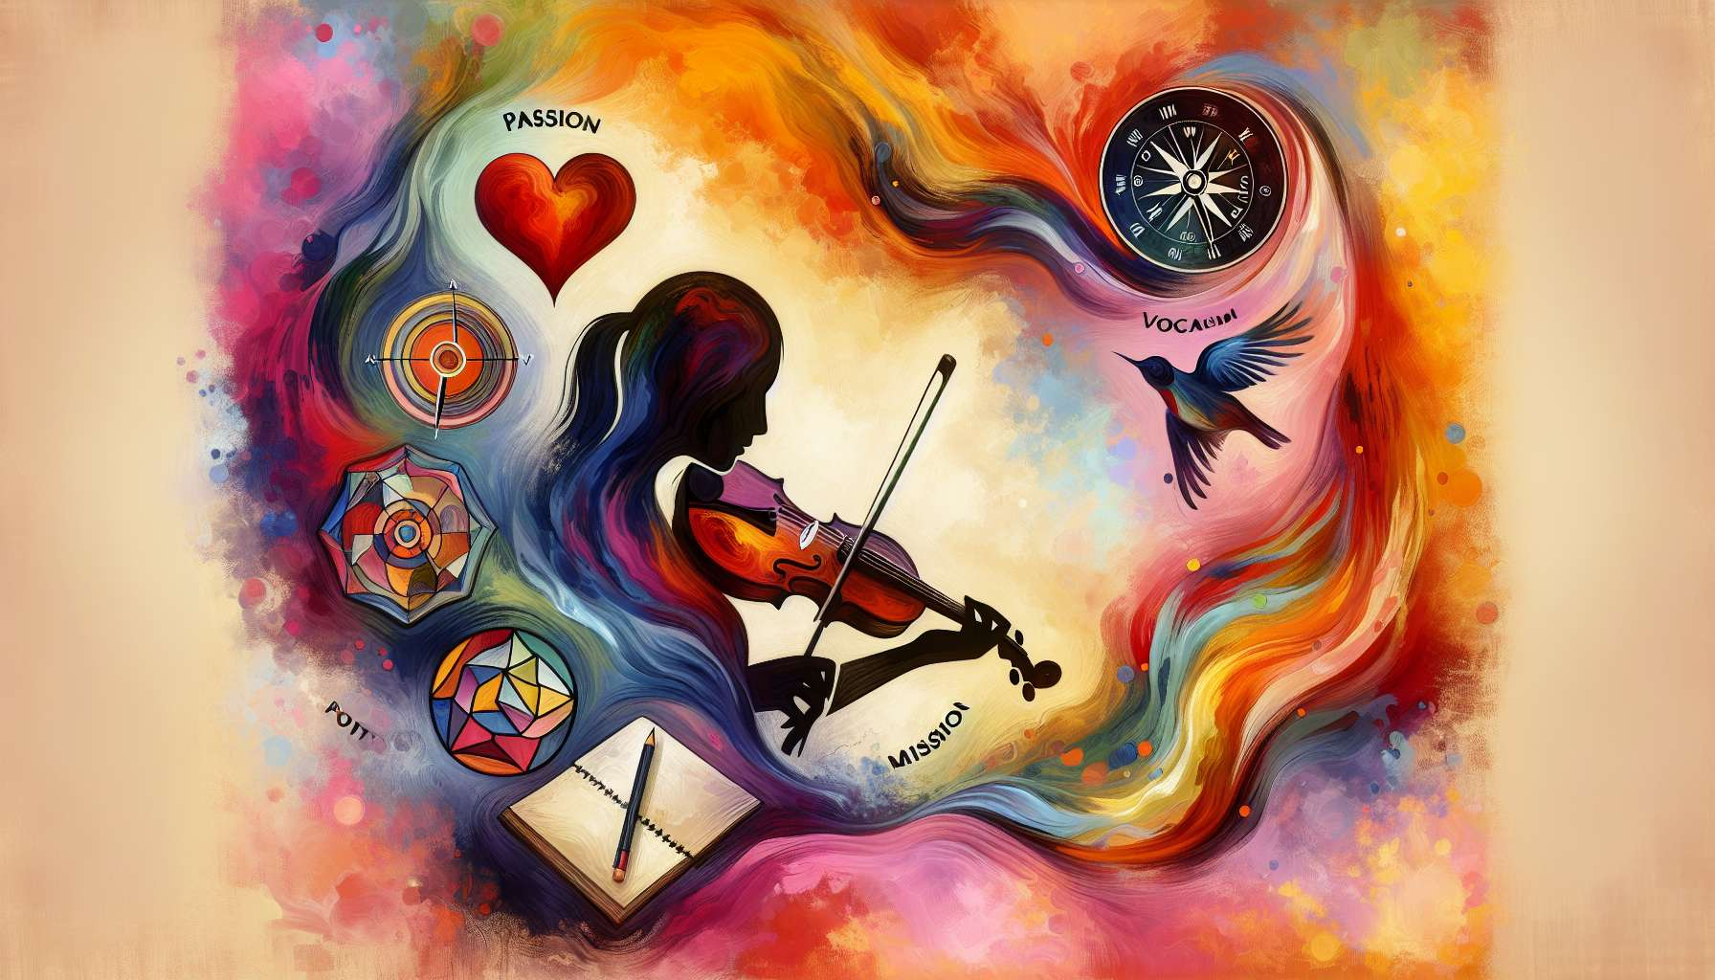

Ikigai and creativity are intimately linked, as they feed each other in a virtuous circle of inspiration and self-realization. Finding your Ikigai is about discovering your purpose, what deeply drives us and gives meaning to our life. It is also about freeing our creative potential, by reconnecting with our deep nature as imaginative and inventive beings.  
  
Creativity is an essential dimension of being human, allowing us to express ourselves, to flourish and transform the world around us. Whether through art, music, writing, cooking, craftsmanship or any other form of expression, creativity invites us to draw from our imagination, experiment with new ideas and bring our inner vision to life. It urges us to step off the beaten path, break conventions, and come up with original solutions to the challenges we face.  
  
Cultivating one's Ikigai, therefore, also means nourishing one's creativity on a daily basis, by allowing ourselves moments of play, exploration, and free expression. It is about allowing oneself to dream, to imagine possibilities and to realize them step by step. It's also about learning to tame your inner critic, that little inner voice that judges and censors us, and letting our creativity emerge without constraints.  
  
For example, an accountant who finds his Ikigai in abstract painting, and makes time every evening for creation in his workshop. By letting himself be guided by his intuition and emotions, he explores new techniques and colors, and creates vibrant canvasses that express his vision of the world. Over time, he gains confidence and creative freedom and discovers a new facet of himself that fills him with joy and pride.  
  
Ikigai acts as a creativity catalyst, reconnecting us to our passions, talents, and deep aspirations. When we are engaged in activities that matter to us and that positively challenge us, we enter a state of flow, where our creativity can fully express itself. We are then totally absorbed by what we do, forgetting about time passing and daily worries. It's in these moments of grace that the most innovative ideas and the most inspired creations often emerge.  
  
Creativity aligned with our Ikigai brings us many benefits, both on a personal, professional, and societal level. On a personal level, it strengthens our self-confidence, our resilience, and our emotional well-being. It allows us to express our uniqueness, develop our potential, and fully flourish. It also teaches us to embrace uncertainty, accept imperfection, and persevere in the face of failure.  
  
Professionally, creativity is a key asset in a constantly changing world where innovation and adaptability are key skills. Whether you're an entrepreneur, artist, or employee, nurturing your creativity allows you to stand out, find original solutions to problems, and create value for yourself and others. It also promotes collaboration, idea sharing, and co-creation in teams.  
  
Societally, creativity is a driver of change and progress, allowing us to imagine and build a better world. When it is put to the service of causes that are close to our hearts, it becomes a powerful lever for social, cultural, and environmental transformation. It pushes us to question the status quo, propose alternatives, and inspire others by example.  
  
Cultivating one's creative Ikigai requires curiosity, bravery, and perseverance. It is about daring to explore new fields, stepping out of one's comfort zone, and challenging oneself. It is also about accepting stumbles, mistakes, and setbacks, using them as opportunities for learning and growth. It is finally about surrounding yourself with inspiring people who nurture our creativity and encourage us to go further.  
  
Finding your Ikigai in creativity, therefore, means giving ourselves permission to fully express our unique potential, aligning our passions, talents, and values. It is about making our life a work of art, filling it with beauty, meaning, and originality. It is about becoming an agent of change, by putting our creativity at the service of our dreams and those of humanity. By cultivating our creative Ikigai, we become creators of the impossible, awakeners of consciousness, and seeders of hope.  
  
Key takeaways :  
  
- Ikigai and creativity are closely linked and feed each other. Discovering your Ikigai helps to unlock your creative potential.  
  
- Creativity is essential for self-expression, flourishing, and transforming the world. It manifests in various forms (art, music, writing, cooking, crafting, etc.).  
  
- Cultivating one's Ikigai involves nourishing one's creativity daily, creating opportunities for free expression and learning how to tame our "inner critic".  
  
- Ikigai acts as a creativity catalyst, reconnecting us to our passions, talents, and deep-rooted aspirations. It fosters a state of flow, which is conducive to the emergence of innovative ideas.  
  
- Ikigai-aligned creativity brings many benefits: self-confidence, resilience, emotional well-being, personal growth, professional adaptability, collaboration, and co-creation.  
  
- Societally, creativity is a driver of change and progress. When utilized for causes close to our hearts, it becomes a lever for social, cultural, and environmental transformation.  
  
- Cultivating your creative Ikigai requires curiosity, bravery, perseverance, and a view of mistakes as learning opportunities. Surrounding yourself with inspiring people is also beneficial.  
  
- Finding your Ikigai in creativity means fully expressing your unique potential by aligning your passions, talents, and values, thus making your life a work of art and becoming an agent of change.