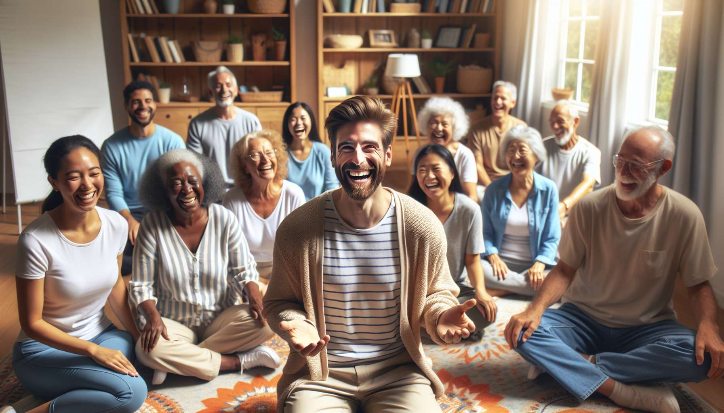

The tips and good practices for a successful laughter therapy animation are the result of the experience, creativity and commitment of practitioners. Beyond techniques and tools, it is the attitude and know-how of the facilitator that make all the difference in creating optimal conditions for laughter to emerge and be shared. Here are some essential keys to cultivate the delicate art of animation.  
  
Firstly, the facilitator must fully embody the values and benefits of laughter. It is not just about transmitting theoretical knowledge, but about being a inspiring and radiant model oneself. By cultivating their own regular laughter practice, and grounding in an authentic joy of living, the facilitator develops a warm and communicative presence that naturally invites relaxation and connection. Participants are not mistaken: a facilitator who laughs with all their heart, with spontaneity and generosity, creates an atmosphere of trust and complicity conducive to laughter.  
  
This authenticity goes hand in hand with high adaptability and creativity. Each group, each session is unique, and the facilitator must know how to improvise and bounce back flexibly in the face of unexpected events. Rather than following a rigid script, they cultivate a sensitive listening and openness to co-create the laughter experience with the participants. They dare to step off the beaten path, propose original variations of exercises, incorporate surprising supports... all while staying focused on the needs and desires of the group. This anchored and adjusted creativity allows for a constant renewal of dynamics and a positive surprise.  
  
Another key ingredient is the art of letting go and benevolent acceptance. The facilitator leads by example by welcoming their own imperfections and clumsiness with humor and lightness. Instead of aiming for a flawless and controlled performance, he fully embraces his vulnerability and humanity, inviting the participants to do the same. Whether the laughter is contagious or shy, raucous or discreet, the main thing is to allow each person to live their unique experience, without judgment or comparison. By downplaying little mishaps and celebrating shared laughter, the facilitator creates a climate of emotional safety and tolerance conducive to authentic expression.  
  
This unconditional kindness also takes shape in the care of the setting and details. Ahead of the session, the facilitator ensures to create a welcoming and comfortable environment, conducive to relaxation and conviviality. During the animation, he is attentive to the physiological and emotional needs of the participants, offering regular breaks, water, tissues... These small attentions show a real consideration for everyone's well-being and contribute to the overall quality of the experience.  
  
A facilitator comfortable with silence and breathing is also a precious asset. In a society where everything moves fast and where the pressure to perform can be strong, providing moments of rest and relaxation is a real gift. The facilitator gently guides moments of refocusing, inviting to savour the benefits of laughter in the body and to integrate learning at their own pace. He punctuates the session with conscious breaths that allows to regulate emotional intensity and cultivate a presence to oneself and the group. Thus, laughter can unfold all its benefits, in a fluid and organic alternation between action and introspection.  
  
The facilitator also cultivates an insatiable curiosity and thirst for learning. Aware that the universe of laughter is vast and constantly evolving, he never stops training and enriching his toolkit. He exchanges with his peers, participates in conferences and seminars, experiments with new approaches... while staying centered on his own style and values. This open-mindedness allows him to constantly renew his proposals and to adapt to different audiences and contexts. Participants appreciate this communicative enthusiasm and this freshness in animation, a sign of a practitioner who does not rest on his laurels but remains in perpetual quest for improvement.  
  
Finally, the facilitator actively cultivates his network and partnerships. Aware that laughter is a tremendous tool for social cohesion and cooperation, he builds links with other actors in the wellness and health field. He imagines joint projects, crosses approaches, pool resources... to multiply the positive impact of laughter on individuals and society. He regularly communicates about his activities, shares his successes and learnings, inspires other vocations.... thereby contributing to the recognition and influence of his profession.  
  
In summary, the tips and good practices of the laughter therapy facilitator are a subtle alchemy between know-how and being. Embodiment, authenticity, creativity, benevolence, presence, curiosity, cooperation... are as many human and relational qualities that enrich technical mastery. It is by cultivating this art of the intelligent heart that the facilitator can fully deploy the treasures of laughter and co-create with the participants a unique shared joy experience, which extends far beyond the session.  
  
Points to remember:  
  
- The facilitator embodies the values and benefits of laughter by cultivating their own practice and being an inspiring and radiant model.  
  
- Authenticity, adaptability and creativity are essential to co-create the laughter experience with participants.  
  
- The facilitator shows letting go and benevolent acceptance by welcoming their own imperfections and allowing each individual to live their unique experience.  
  
- Kindness is demonstrated in the care of the setting and details, creating a welcoming and comfortable environment.  
  
- The facilitator is comfortable with silence and breathing, offering moments of rest and relaxation to savor the benefits of laughter.  
  
- Curiosity and a thirst for learning push the facilitator to continually train and enrich their toolkit.  
  
- The facilitator actively cultivates his network and partnerships to multiply the positive impact of laughter on individuals and society.  
  
- Tips and good practices are a subtle alchemy between know-how and being, blending human and relational qualities with technical mastery.