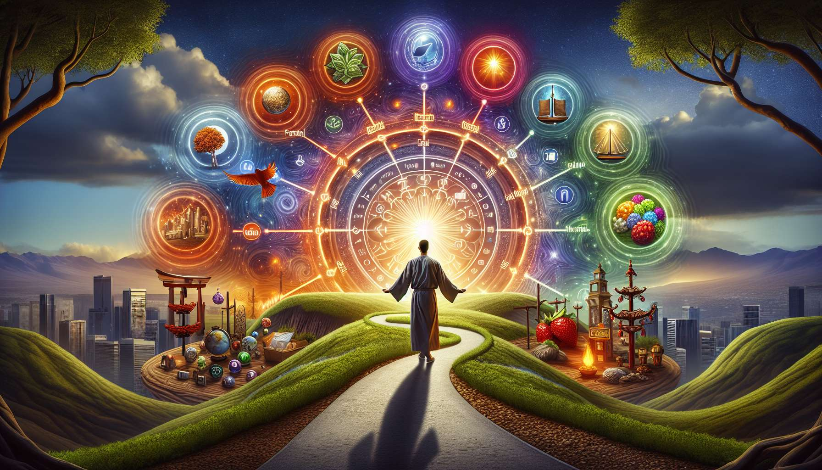

Ikigai is a wonderful tool for giving meaning and direction to our personal goals. Once we have identified what deeply moves us, what gives value to our life, setting aligned goals with our purpose becomes much easier and natural.  
  
Imagine that your Ikigai is to "create beauty to inspire others". Your personal goals will naturally stem from this life mission. For example, you could set a goal to learn new artistic techniques, create one piece of artwork a month, exhibit your work, collaborate with other inspiring artists, etc. Each goal, from the smallest to the most ambitious, will be a way to nurture and express your Ikigai.  
  
Ikigai also encourages us to choose goals that have meaning to us, rather than following societal or other people's expectations. When our goals resonate with our values and deepest aspirations, we are much more motivated to invest in achieving them. We tap into our energy and creativity to overcome obstacles and persist.  
  
Another valuable contribution of Ikigai is to motivate us to choose balanced objectives, which nourish the different dimensions of our life - personal, relational, professional, spiritual... Rather than focusing on one area to the detriment of others, Ikigai reminds us of the importance of a harmonious life where each sphere contributes to our overall fulfillment.  
  
For example, your Ikigai could be "transmitting your knowledge to help others thrive". Your goals will then reflect this quest for sharing and contribution. You could aim to become a trainer in your field of expertise, write a practical advice book, create a blog or a YouTube channel to share your knowledge, organize workshops, become a mentor... All the while making sure to reserve quality time for your loved ones and for self-care.  
  
Thus, Ikigai transforms our relationship to goals. It's no longer about just reaching results or ticking boxes, but about engaging in a meaningful journey. Each step, every small step becomes a way to honor and live our Ikigai. The journey becomes as important as the destination.  
  
Of course, our goals can evolve over time, with our experiences and new aspirations. Ikigai is not a fixed concept, it is revealed and refined throughout our lives. Our goals will adjust accordingly, reflecting our personal growth and evolution.  
  
By integrating the concept of Ikigai into our way of choosing and pursuing our goals, we give them a deeper and more inspiring dimension. We are no longer just aiming to perform or succeed, but to fully achieve ourselves and contribute to the world in a unique way. Our goals then become a reflection of our raison d'être and our will to live a meaningful life.  
  
Key takeaways:  
  
- Ikigai helps give meaning and direction to our personal goals by aligning them with our deep purpose.  
  
- When our goals resonate with our values and aspirations, we are more motivated to invest ourselves to achieve them.  
  
- Ikigai suggests choosing balanced goals that nourish the different spheres of our life (personal, relational, professional, spiritual) for overall fulfillment.  
  
- With Ikigai, achieving goals is not about getting results but becomes a meaningful journey where each step allows us to honor our purpose.  
  
- Our goals evolve over our lifetime, reflecting our personal growth, just as our Ikigai is refined with our experiences and new aspirations.  
  
- Integrating Ikigai into our goals gives them a deeper and more inspiring dimension, for our full realization and unique contribution to the world.